The 19th century oversaw several art periods: the impressionist movement, the post-impressionism, realist art and others. These art periods have largely contributed to the world that we currently live in many ways, whether they are paintings, photography or other mediums of art. One of the mediums of art that has predominantly been produced is architecture, in which, there are several notable places that stand out from the surrounding buildings, such as The Eiffel Tower of Paris and the Brooklyn Bridge of New York City - both built in the 19th century, in which, though they are in completely different locations and may be built to different purposes, they have several similarities that show how these two structures are actually more alike than we may think.

The Eiffel Tower was constructed for the International Exposition of 1889 (1889 Exposition Universelle) by the French government to celebrate the 100th anniversary of the French revolution. The concept of the Eiffel Tower was designed and submitted by Gustave Eiffel outlining a 300-meter tower. The design illustrates a 300-meter tower with four iron lattice-girder piers separated at the base and gradually coming together at the top where they are joined by metal girders at two levels, which in turn, also provide viewing platform for tourists. The construction began on January 1887 and finished on March 31st, 1889; 150 to 300 workers were involved in the construction.

Figure 1 displays a front view of the Eiffel Tower. The tower, following Eiffel’s design, has the four pillars at the base that gradually come together when going upwards the tower and eventually is joined into the single tower top, the highest level of the tower where it is currency occupied by broadcast antennas for public broadcast radio stations. The tower has four sides and each side faces four different views, they are: the hill of Chaillot, the historic center of Paris, the Grenelle neighborhood, and the Champ-de-Mars garden. The tower contains three floors. There are several decorations and features that the tower has, such as, the feet of the tower that contains the names of the scientists and civil engineers that are part of the project (Figure 2), the elevators that ascend along the curve of the tower (Figure 3).
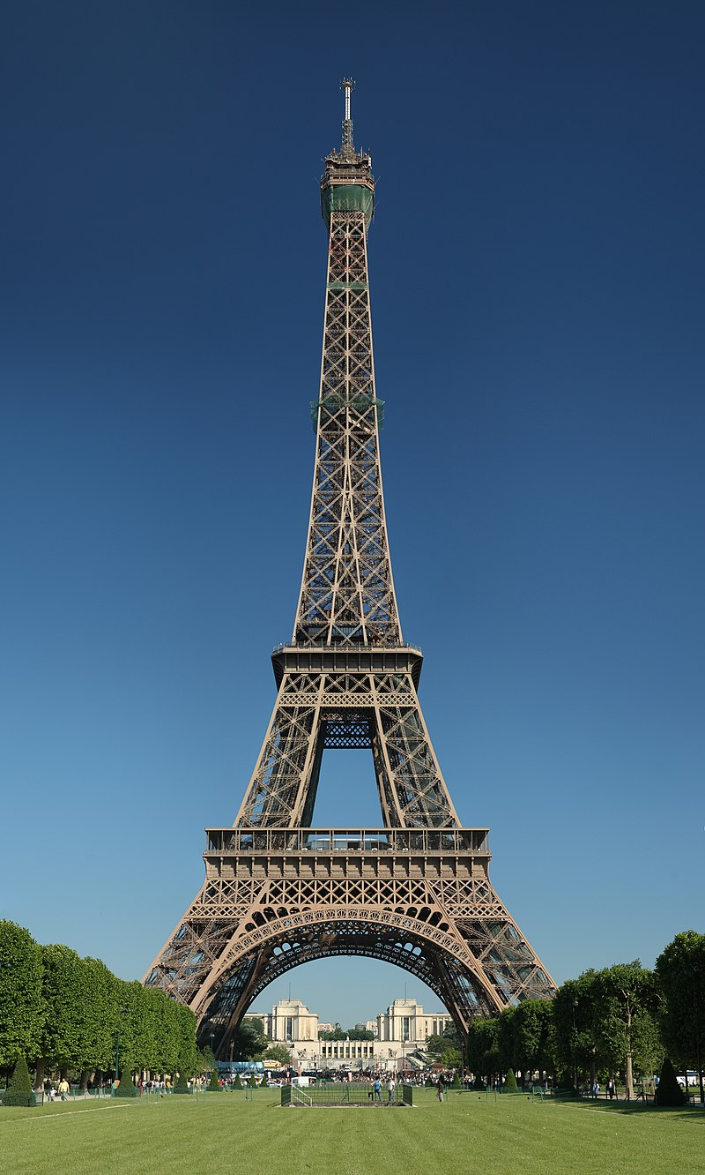Figure 1: Gustave Eiffel, The Eiffel Tower, 1889, Steel with iron coating, 324 m x 125 m x 125 m
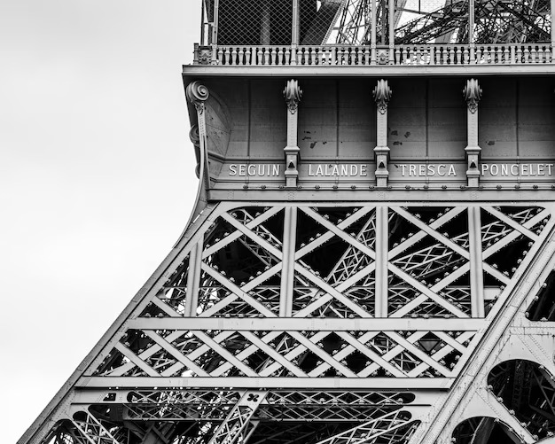Figure 3: Close-up on the names of the The Eiffel Tower
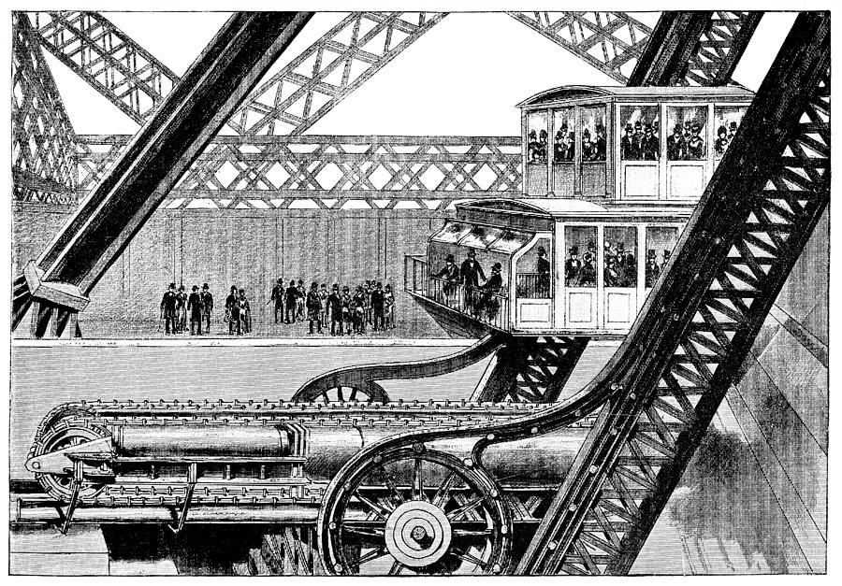Figure 2: Close-up on the elevator of the Eiffel Tower, Gustave Eiffel, The Eiffel Tower, 1889

In terms of the design of the architecture. The Eiffel Tower demonstrates a clear departure from neo-gothic, neo-renaissance and neo-baroque architecture styles that were predominant during the 18th and the 19th century and moving towards a modern-style architecture due to the use of iron as well as the glass floor. Due to its breakaway from the historic architecture style, it was met with criticisms from various artists and media; these examples include: the article titled “Protest against the Tower of Monsieur Eiffel” or claims that the tower looks like a “tragic street lamp” or “a belfry skeleton” and “iron gymnasium apparatus, incomplete, confused and deformed.” by several satirists However, these criticisms quickly vanished after the completion of the towers’ construction and due to its success that it received from visitors.

Meanwhile, across the Atlantic Ocean in New York City, four years before the construction of the Eiffel Tower in Paris, the construction of what is now the infamous Brooklyn Bridge had finished. The Brooklyn Bridge is a suspension bridge spanning from the East River of Brooklyn to Manhattan (Figure 4); its total length to be 6,016 feet or 1,834 meters long making it the longest suspension bridge in the world at the time.
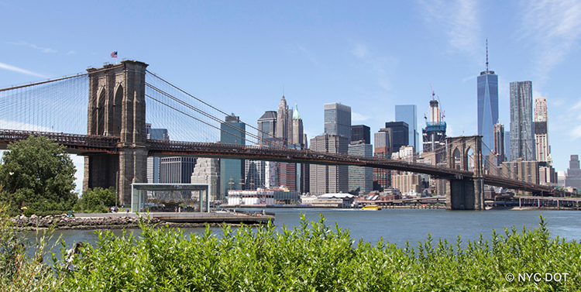Figure 4: The Brooklyn Bridge, New York City
The Brooklyn Bridge was designed by a German immigrant engineer, John Augustus Roebling, in which, he proposed a design of the suspension bridge over the East River in 1857 after the passing of the bill that enabled the construction of the bridge by the New York State’s Senate, the construction began on January 2nd 1870, where it was administered by the New York and Brooklyn Bridge company. The construction of the bridge finished in 1883 and finally opened to the public on May 24th, 1883.

The design of the bridge was a blend or a mix of two different styles of architecture, Gothic architecture was used specifically for the towers that hold up the cables and Modern architecture was used in other areas of the bridge such as the deck and the cables. The towers that hold up the bridge were built of limestone, granite and cement (Figure 6); each of them contains two neo-Gothic pointed arches and was constructed to be 278.25 feet tall or 84.81 meters fall above water. The use the said materials created the Gothic-style towers that is similar to ones used in Catholic churches and other buildings such as the Manchester Town Hall in the United Kingdom, the Hungarian Parliament Building in Hungary, creating a feeling of a palace or a castle when entering the bridge and exiting the bridge when driving by.
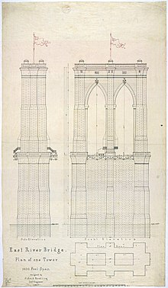Figure 5: Early Brooklyn Bridge tower plan, 1867
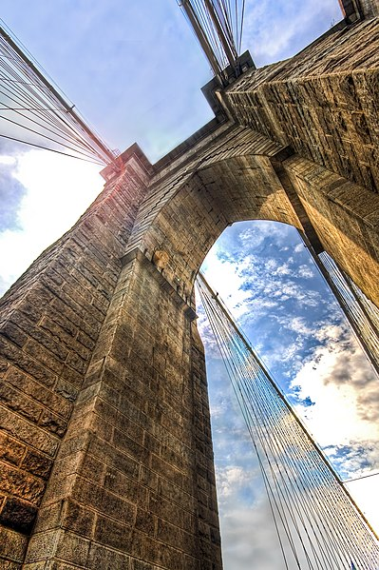Figure 6: Towers of the Present Day Brooklyn Bridge, 2008

On the other hand, Roebling went for another approach when it comes to the deck and the cables for the bridge. For the cables (Figure 7), he used steel for the cables that descend from the top of the suspension towers and help hold the deck. These cables are galvanized steel wires wired into 19 individual strands; these cables took several months for the constructions workers to tie together. For the deck, Roebling went with a structure that contains multiple trusses, made with steel, enabling the bridge to handle a total load of 18,700 short tons or 16,964 metric tons. Roebling’s approach not only created a bridge that has the strength to handle an enormous amount of vehicles his approach also contributed to the new style of architecture where it is now widely known as modernist architecture.
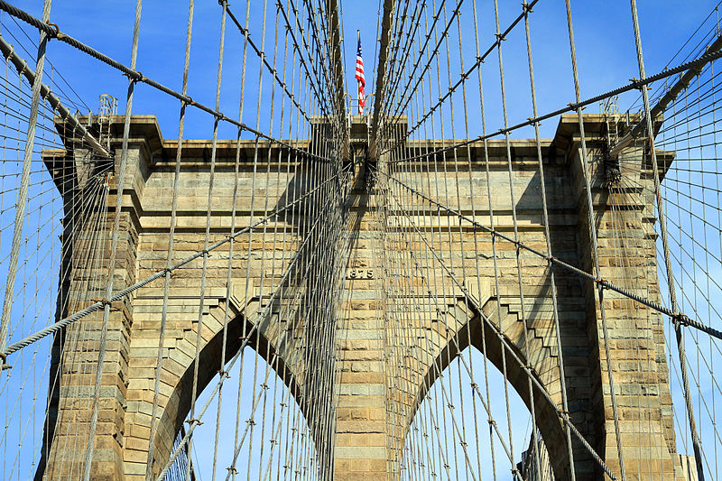Figure 7: View of suspender cables of the bridge, 2013

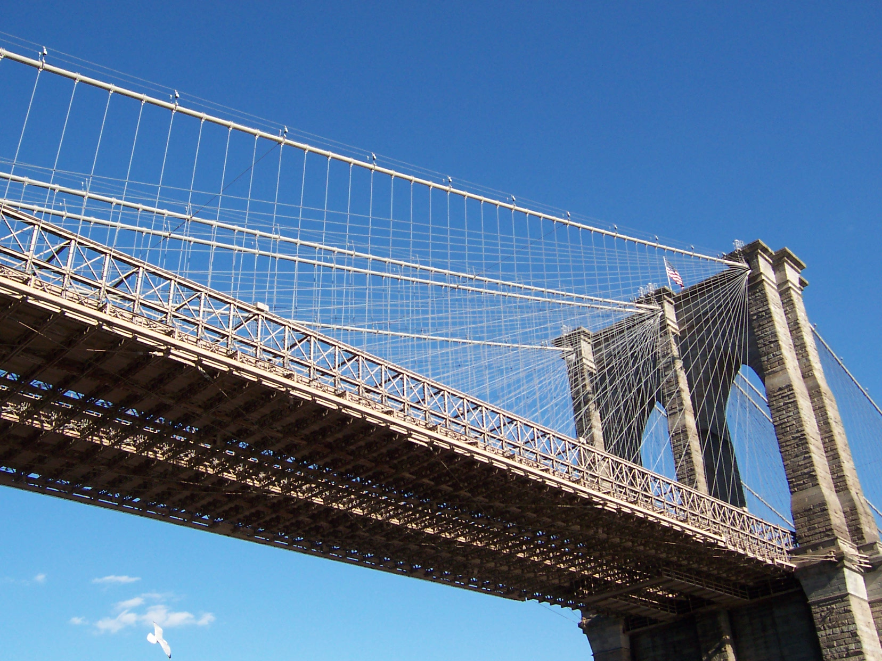Figure 8: View of the Brooklyn Bridge from below

These two structures, though are distanced far away from each other, they have several similarities in terms of their contribution to modernist architecture. The Eiffel Tower and the Brooklyn Bridge both use similar materials such as steel to incorporate into their builds which led to a new

https://www.britannica.com/topic/Eiffel-Tower-Paris-France
https://www.toureiffel.paris/en/the-monument/history
https://www.livescience.com/29391-eiffel-tower.html
Figure 2: https://www.freepik.com/free-photo/closeup-greyscale-shot-eiffel-tower-paris-france_10722501.htm
Architectural plans and drawings of the Brooklyn Bridge. (n.d.). The New York Public Library. https://www.nypl.org/events/exhibitions/galleries/new-york-city/item/15848
Brown, F. (2008). Eiffel’s Tower. New England Review (1990-), 29(4), 7–24. http://www.jstor.org/stable/40245152
Cruise, R. (2020). The 300m Eiffel Tower: The role of a structural principle. Construction History, 35(2), 43–66. https://www.jstor.org/stable/27135898
https://www.nyc.gov/html/dot/html/infrastructure/brooklyn-bridge.shtml
https://www.britannica.com/topic/Brooklyn-Bridge
https://classicnewyorkhistory.com/history-of-the-brooklyn-bridge/
McCullough, D. (1972). The Great Bridge. Simon & Schuster. ISBN 978-0-671-21213-1
McCullough, D. (2012). The great bridge: the epic story of the building of the Brooklyn Bridge. Simon and Schuster. https://books.google.com/books?hl=vi&lr=&id=KtowBwAAQBAJ&oi=fnd&pg=PA12&dq=how+many+people+die+during+the+brooklyn+bridge+construction&ots=KmViGtPfWI&sig=WU5noBTbfryxWaxvSC1OdHw2WGU
Mehren, E.J.; Meyer, H.C.; Wingate, C.F.; Goodell, J.M. (1889). Engineering Record, Building Record and Sanitary Engineer. McGraw Publishing Company. p. 105

