Error conditions
- If no input was entered when asked
- Student ID is not 8 digits long
- Incorrect dates
Boundary Conditions
- User entered zero students
- User entered 200 students

Successive Refinement Diagram

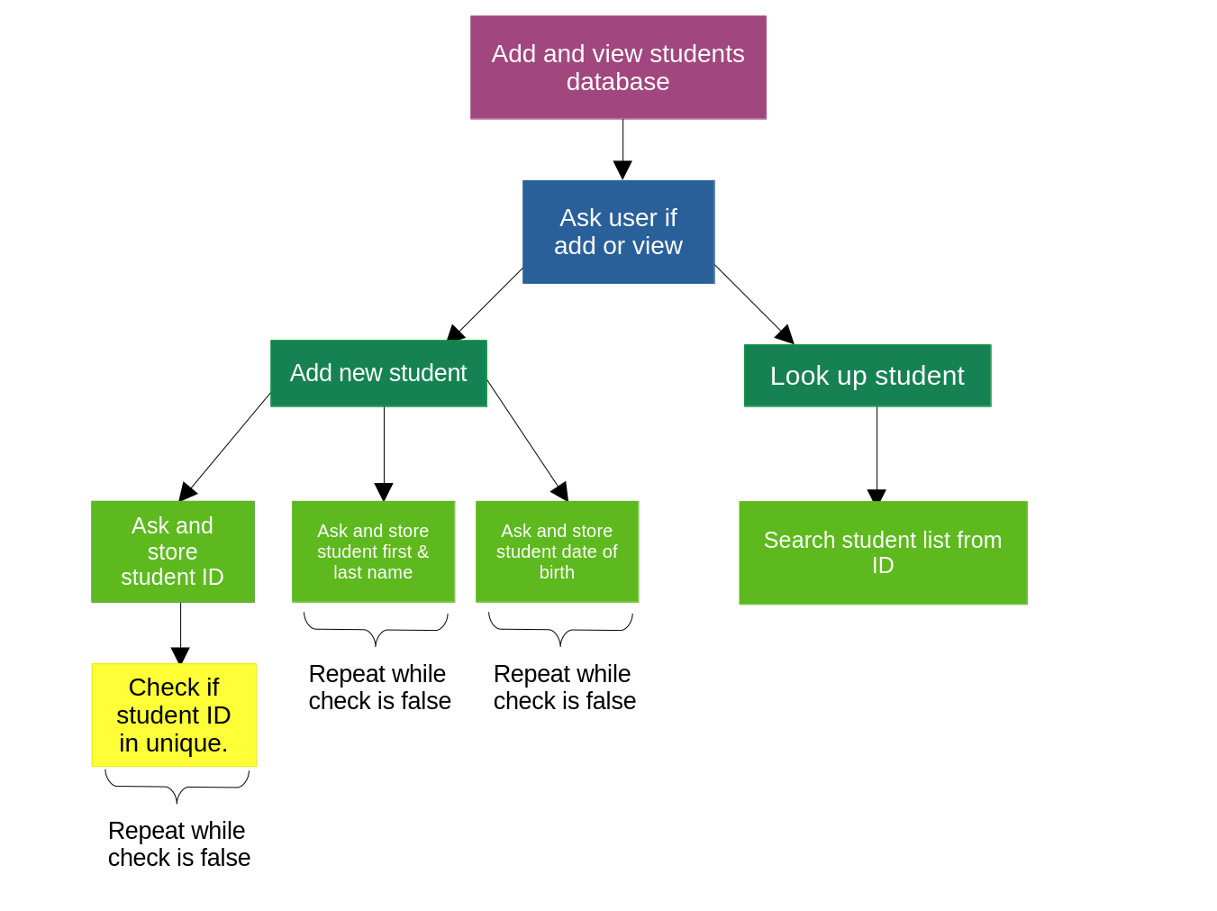

Top-Level Pseudocode

set num_of_students = 0
repeat
print options
ask for option
if option is 1
do Add student to list (see below)
else if num is 2
do Search for student in list (see page 4)
else if num is 0
exit
else
print error message “Invalid option number”
endif
endrepeat

Add student to list

if num_students is 200
print “Sorry, this program only handles up to 200 students”
return to Top-Level Pseudocode
endif
do Get and store student ID (see below)
do Get and store student name (see page 3)
do Get and store student birth date (see page 3)
add 1 to num_students
return to Top-Level Pseudocode

Get and store Student ID

set check to false
repeat while check is false
set check to true
if length of student ID is not 8
print error “ID must be 8 digits”
set check to false
else if input is not a number
print error “Only accepting numbers”
set check to false
else if student ID is not unique (see page 3)
print error “must be unique”
set check to false
endif
endrepeat

Get and store student name

set check to false
repeat while check is false
set check to true
get first and last name
if no input
print error message “Please enter first and last name”
set check to false
else if two strings no separated by space
print error “Please enter both first and last name”
set check to false
else if first or last names have special characters
print error “Do not use special characters”
set check to false
endif
endrepeat

Get and store student birth date

set check to false
repeat while check is false
set check to true
get student birth date
if length of student birth date is not 10
print error “Please enter date as dd/mm/yyyy”
set check to false
else
separate day, month and year as integers
if year is less than 1990 or more than 2010
print error “Invalid year, please enter between 1990 and 2010”
set check to false
else if month is not between 1 and 12
print error “Invalid month, please enter between 1 and 12”
set check to false
else if day is less than 1 or more than max number of days in month
print error “Invalid day”
set check to false
endif
endif
endrepeat

Check if ID is unique

repeat while students are left in list
if new ID is the same as this student ID
return false
endif
endrepeat
return true
Search for student in list

if num_of_students is 0
print “No students entered.”
else
repeat while there are students in list
if input ID is the same as this student ID
print name and birth date for matching student
return true
endif
endrepeat

print “Cannot find student with the ID: `input `”
return false

