- The probability that the blue team wins is approximately 0.5 or 50% (real number: 0.499) which is calculated through counting all of the events that blue team won and dividing that data with the all events that happened, in this case, games.
- The probability that the blue team wins and kills the dragon is 0.232 or around 23% which is calculated through counting all the events that blue team won and them killing the dragon and dividing the figure by the total amount of games played.
- The probability that the blue team wins and kills the herald is 0.112 or around 11% which is calculated by counting said events and dividing the number by total games played.
- The Venn Diagram is shown below.
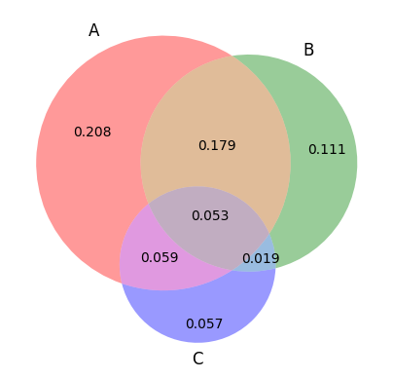
The data shown is calculated from three different events:
A: 2055 - Events that blue team wins
B: 1096 - Events that blue team wins and kills the dragon
C: 564 - Events that blue team wins and kills the herald.
Which was then inputted to venn3 function to create a Venn diagram that displays all the information including the intersections.
The figures from the first Venn diagram were then used to calculate each of its probability value by dividing each figure by num_game or the number of games in total.
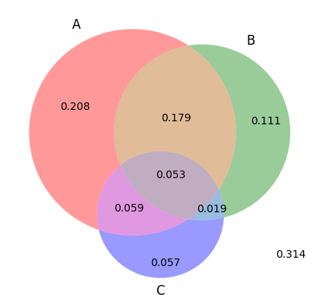
- The probability of the event (A ∪ B ∪ C)^{C} is 0.314 and is shown in the following Venn diagram and is essentially the value that complements the data inside the Venn diagram or the wins.
- The event of (A ∩ B ∩ C) is essentially describing the event that the blue team wins the game, kills the dragon and the herald, which corresponds to the center part of the Venn diagram with the value of 0.053 or around 5%.
- The probability that blue team kills the dragon and the herald but does not win is essentially the intersection between the B and C circle which is the value of 0.019 or approximately 2%.
- The probability that blue team wins without killing the dragon and the herald is essentially the value of the A circle which is 0.208 or 2%.

