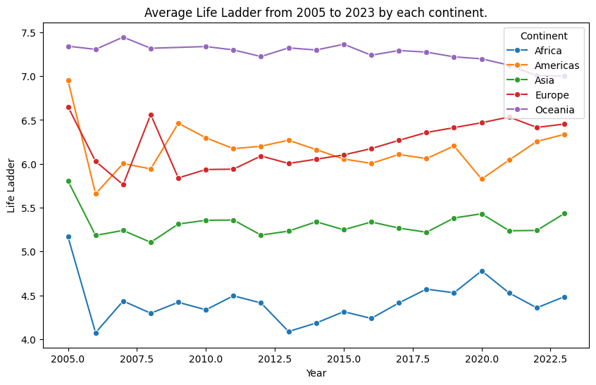
- The instructions first define the variable for the graph as “Life Ladder”, followed by grouping the data into two groups, first, the “year” group and then the “Continent” group, followed by calculating the mean value for each group and ends with resetting the index in the DataFrame, in this case, the Dat[[‘year’, ‘continent’]] and use the default index value instead.
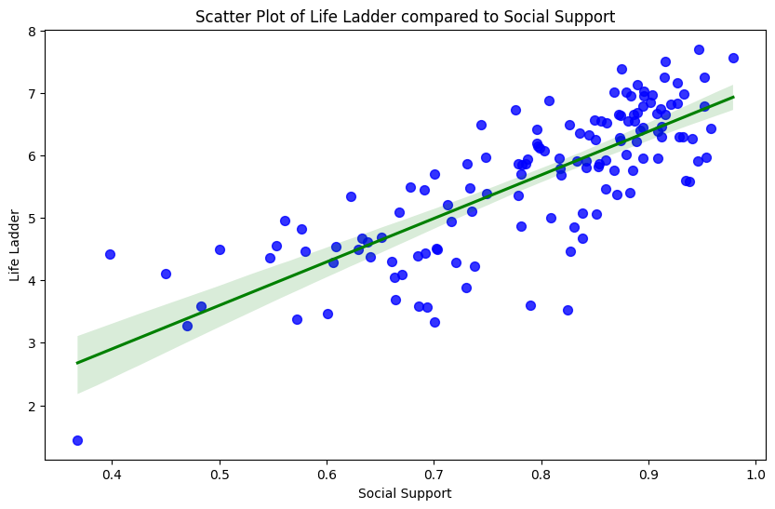
- The scatter plot along with the inclusion of the regression line describes the relationship between the Life Ladder variable and the Social Support variable. The graph shows a general trend where the higher the Social Support variable is, the higher the Life Ladder variable is, though, there may be several outliers.

- The following graph describes the 5 happiest countries and the 5 unhappiest countries in the world. 5 happiest are Finland, Iceland, Denmark, Costa Rica and the Netherlands. The 5 unhappiest are Afghanistan, Malawi, Botswana, Democratic Republic of the Congo and Sierra Leone. Higher value (in this case, colored in green) means happier and lower value (in this case, in red) means less happy.
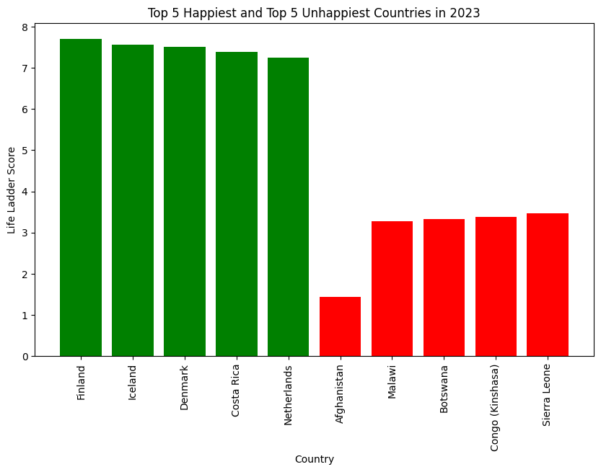

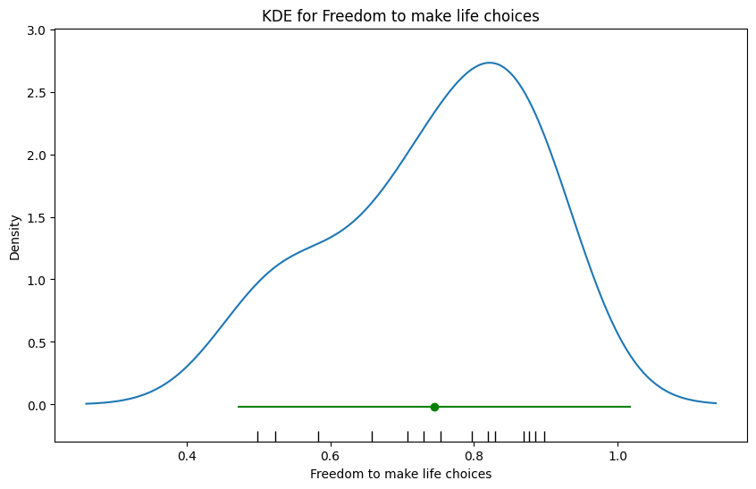
- Name: Thailand – Subregion: Southeastern Asia – Variable: Freedom to make life choices
In this graph, we can see that there are data points in the bottom are in the range between 0.4 and 1.0, and when translated into a graph, the height of the blue line essentially describes the amount of data in that range. For example: There are more data points concentrated in 0.8 – 1.0 range than data points concentrated between 0.5 and 0.8, thus, height of the blue line of the 0.8 – 1.0 range is more than that of the 0.5 – 0.8 range.

