Successive Refinement Diagram

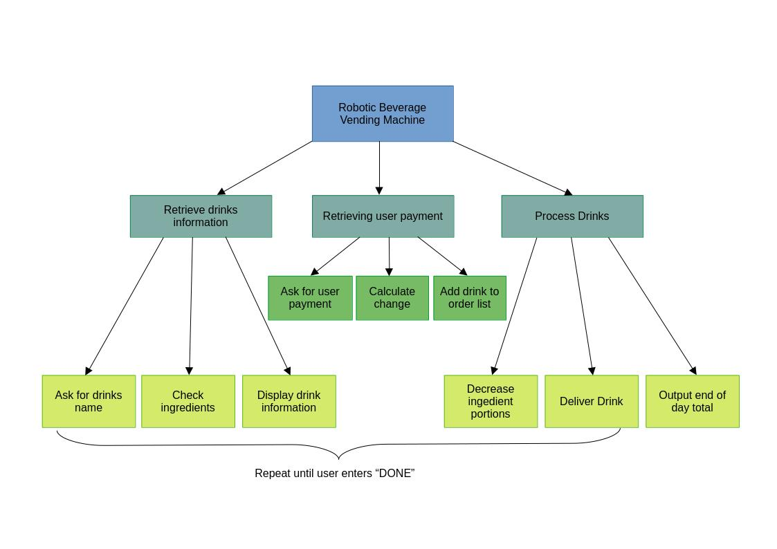

Top Level Algorithm
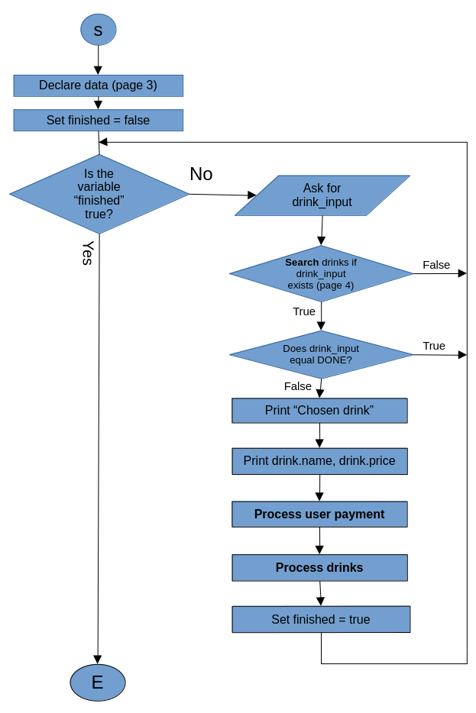
Declare data

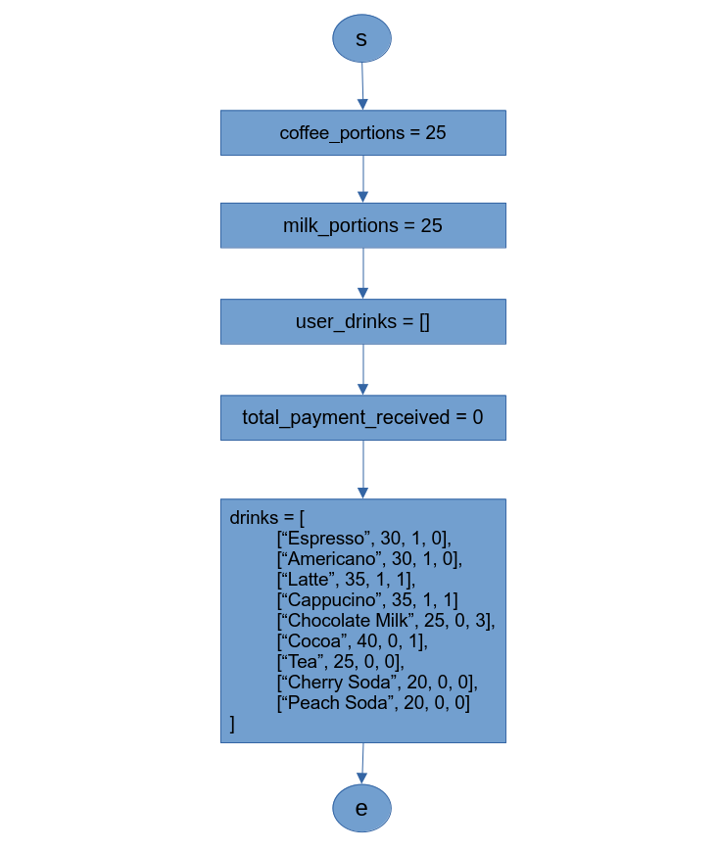
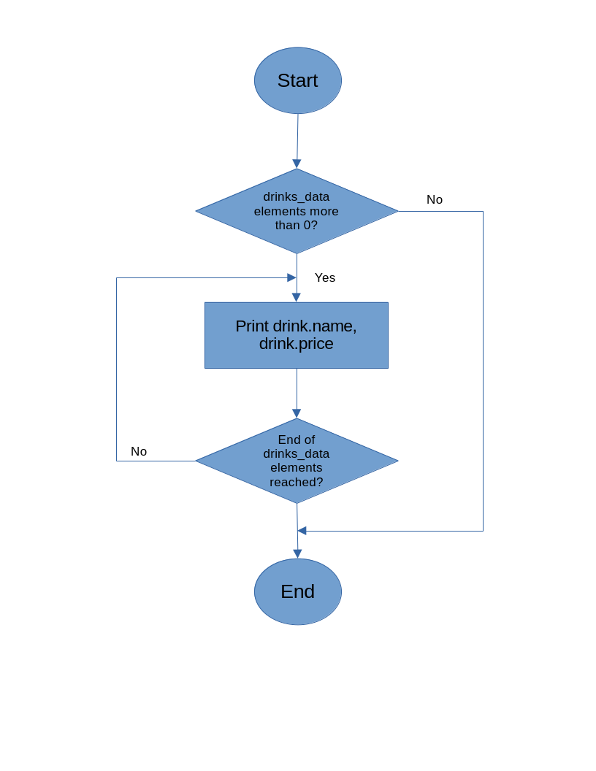
Display drink menu
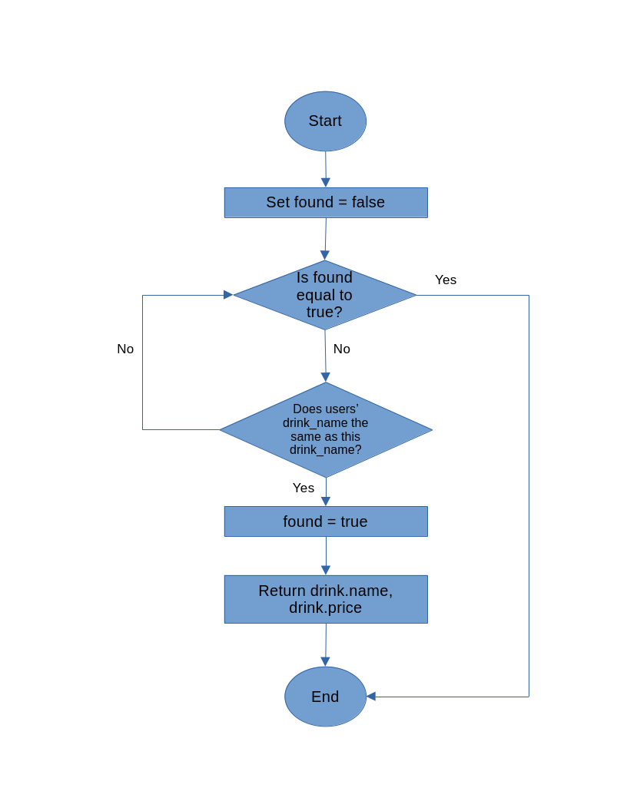
Search for drink
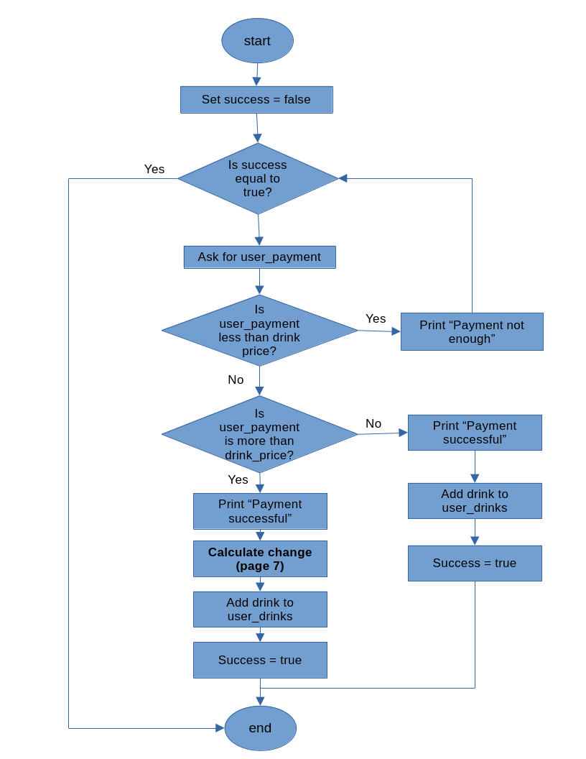
Process User Payment
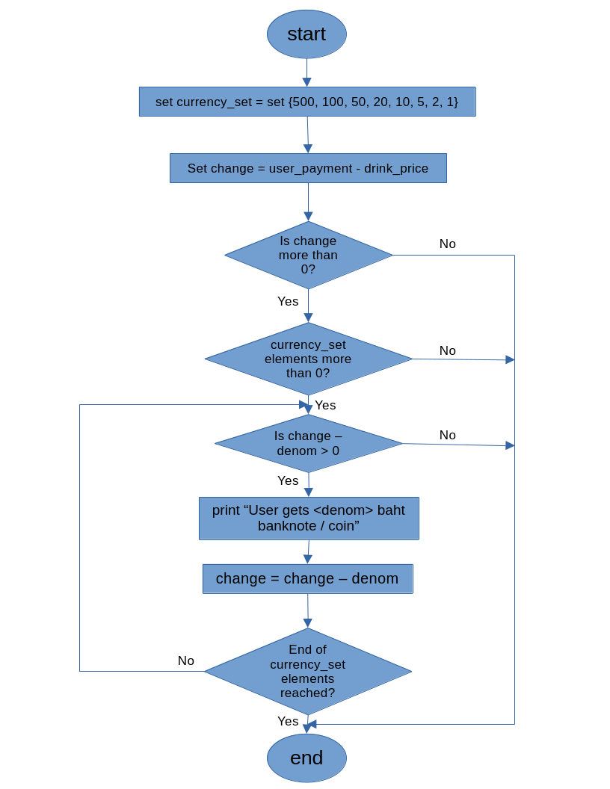
Calculate Change

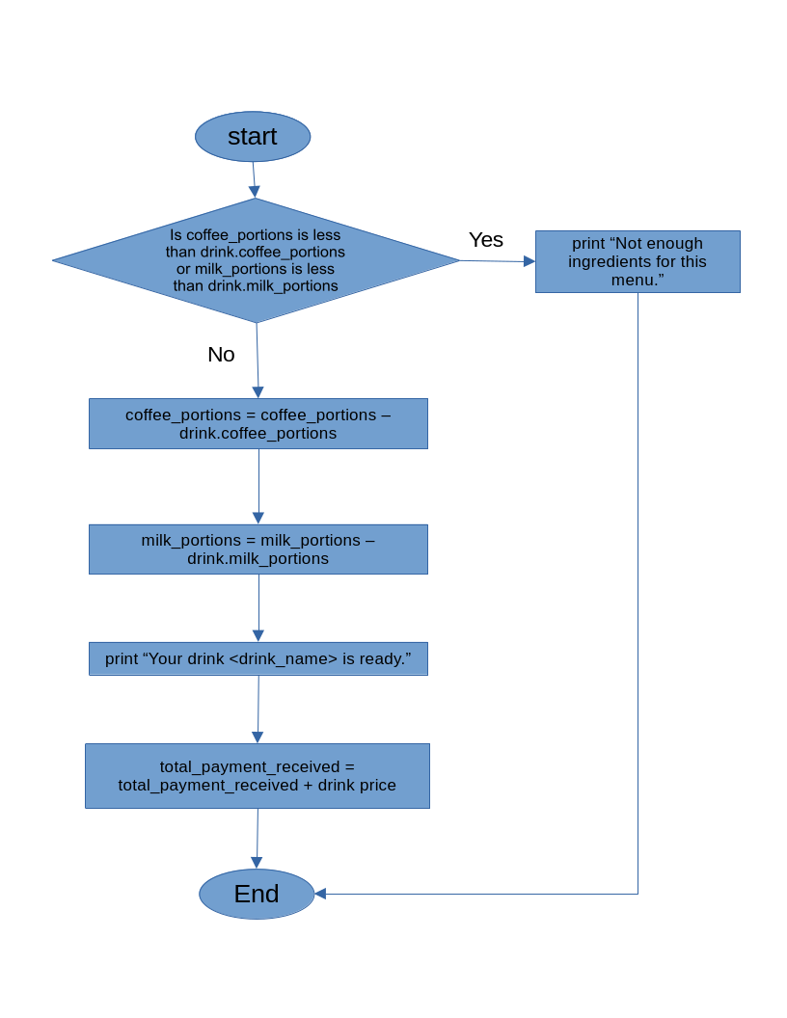
Process Drink
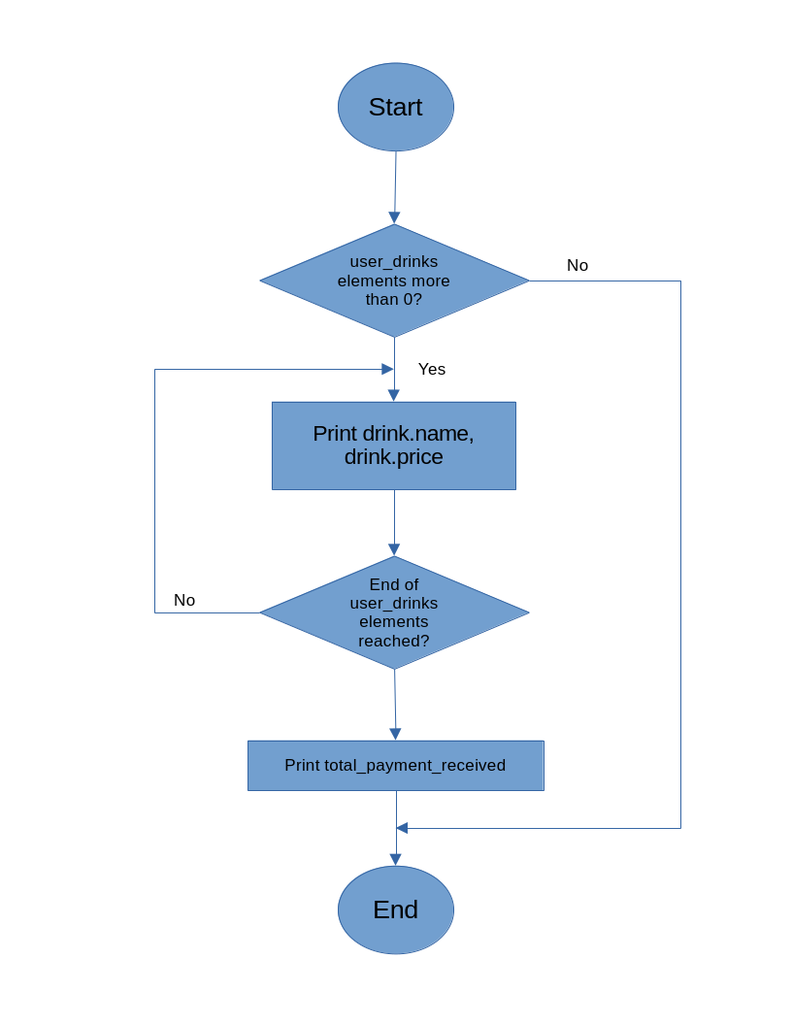
Output Summary
Pseudocode

Declare data (page 9)
set finished = false
repeat until finished is true
Display drink menu (page 10)
ask for drink_input

if Search drink_input (page 10) is false
print “Drink not available”
else if drink_input is “DONE”
finished = true
else
print “Chosen drink: ”
print drink.name, drink.price
Process user payment (page 10)
Process Drinks (page 11)
finished = true
endif
endrepeat

Output summary (page 11)

Declare Data
set coffee_portions = 25
set milk_portions = 25
set user_drinks = []
set total_payment_received = 0
set drinks = [
[“Espresso”, 30, 1, 0],
[“Americano”, 30, 1, 0],
[“Latte”, 35, 1, 1],
[“Cappucino”, 35, 1, 1]
[“Chocolate Milk”, 25, 0, 3],
[“Cocoa”, 40, 0, 1],
[“Tea”, 25, 0, 0],
[“Cherry Soda”, 20, 0, 0],
[“Peach Soda”, 20, 0, 0]

Display drink menu
foreach drink in drinks_data
print drink.name, drink.price
endfor

Search for drink
set found = false
repeat until found is true
if input drink_name is the same as this drink_name
found = true
return drink.name, drink.price
endif
endrepeat

return false

Process User Payment
set success = false
repeat until success is true
ask for user_payment
if user_payment is less than drink_price
print “Payment not enough”
else if user_payment is more than drink_price
print “Payment successful”
Calculate change (page 11)
add drink to user_drinks
success = true
else
print “Payment successful”
add drink to user_drinks
success = true
endif
endrepeat

Calculate Change
set currency_set = set {500, 100, 50, 20, 10, 5, 2, 1}
set change = user_payment – drink_price
repeatwhile change > 0
foreach denom in currency_set
repeat while change – denom > 0
print “User gets <denom> baht banknote / coin”
change = change – denom
endrepeat
endfor
endrepeat

Process Drinks
if coffee_portions is less than drink.coffee_portions or
milk_portions is less than drink.milk_portions
print “Not enough ingredients for this menu.”
else
coffee_portions = coffee_portions – drink.coffee_portions
milk_portions = milk_portions – drink.milk_portions

print “Your drink <drink_name> is ready.”
endif

total_payment_received = total_payment_received + drink price

Output Summary
foreach drink in user_drinks
print drink name, drink price
endfor
print total_payment_received

