Successive Refinement Diagram

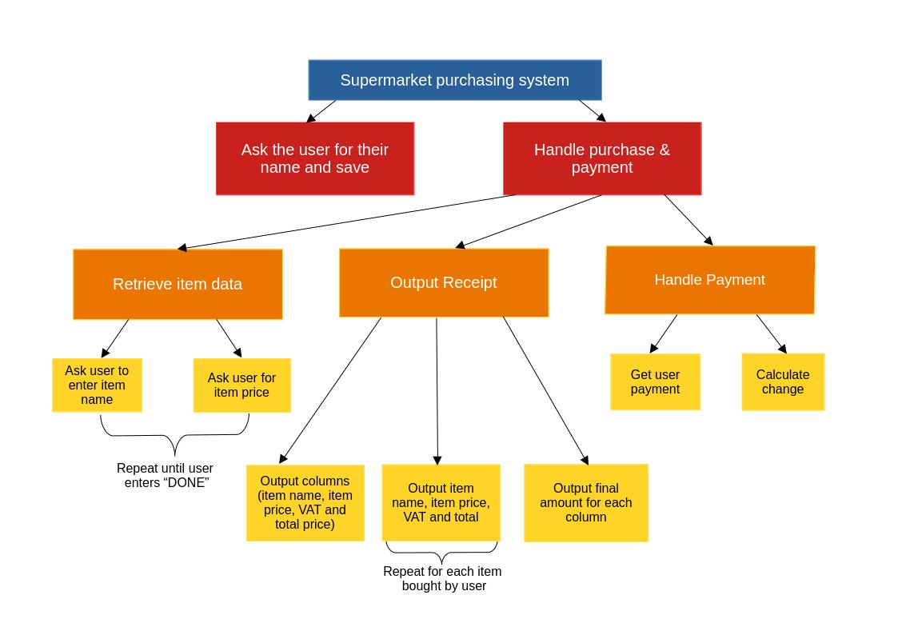

Pseudocode

Retrieve Item data

get item_name
Repeat while item name is not “DONE”
get item_price
save item_name and item_price in item_set
get next item_name
Endrepeat

Output Receipt

print column headers [“Name”, “Item Price”, “VAT”, “Total”]
set total_items_price = 0;
set total_vat = 0;
set final_total = 0;
foreach item in item_set
set vat = 0;
if item_price >= 100
set vat = item_name * 0.07
endif

print item_name, item_price, vat, (item_name + vat)
set total_items_price = total_items_price + item_price
set total_vat = total_vat + vat
set final_total = final_total + item_price + vat
endfor
print “Total”, totel_items_price, total_vat, final_total

Handle Payment

get user_payment
repeatwhile user_payment < amount_owed
print error message “Payment not enough.”
get user_payment
endrepeat
if user_payment > amount_owed
do calculate change
endif

Calculate Change

set denominations = set {500, 100, 50, 20, 10, 5, 2, 1}
set change = user_payment – amount_owned
repeatwhile change_owed > 0
foreach denom in currency_set
repeat while change – denom > 0
print “User gets <denom> baht banknote / coin”
change = change – denom
endrepeat
endfor
endrepeat

Top Level Algorithm

Ask user for name and save
Do Retrieve item data (page 2)
Do Output receipt (page 2)
Do Handle Payment (page 2)

