Successive Refinement Diagram

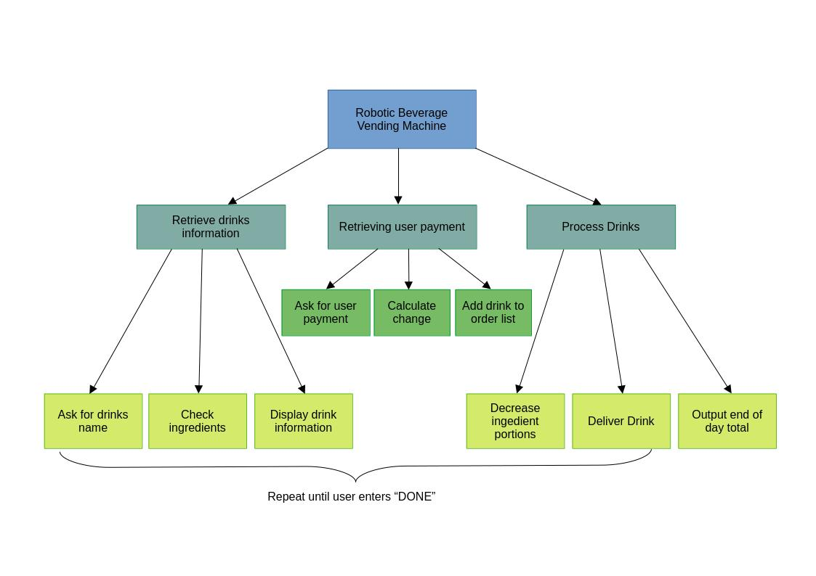

Top Level Algorithm

set coffee_portions = 25
set milk_portions = 25
set drinks = [
[“Espresso”, 30, 1, 0],
[“Americano”, 30, 1, 0],
[“Latte”, 35, 1, 1],
[“Cappucino”, 35, 1, 1]
[“Chocolate Milk”, 25, 0, 3],
[“Cocoa”, 40, 0, 1],
[“Tea”, 25, 0, 0],
[“Cherry Soda”, 20, 0, 0],
[“Peach Soda”, 20, 0, 0]
]

set finished = false
set user_drinks = []
set total_payment_received = 0

repeat until finished is true
foreach drink in drinks_data
print drink.name, drink.price
endfor
ask for drink_input
if Search drink__input is false
print “Drink not available”
ask for drink_input
else
print drink.name, drink.price
Process user payment
Process Drinks
endif
endrepeat

foreach drink in user_drinks
print drink name, drink price
endfor
print total_payment_received

Search for drink

repeat
if input drink_name is the same as this drink_name
return drink name, drink price
endif
endrepeat

return false

Process User Payment

set success = false
repeat until success is true
ask for user_payment
if user_payment is less than drink price
print “Payment not enough”
else if user_payment is equal to drink_price
print “Payment successful”
add drink to user_drinks
success = true
else if user_payment is more than drink price
Calculate change
add drink to user_drinks
success = true
endif
endrepeat

Calculate Change

set currency_set = set {500, 100, 50, 20, 10, 5, 2, 1}
set change = user_payment – drink_price
repeatwhile change_owed > 0
foreach denom in currency_set
repeat while change – denom > 0
print “User gets <denom> baht banknote / coin”
change = change – denom
endrepeat
endfor
endrepeat

Process Drinks

coffee_portions = coffee_portions – drink.coffee_portions
milk_portions = milk_portions – drink.milk_portions

print “Your drink <drink_name> is ready.”

total_payment_received = total_payment_received + drink price

