Numeral System and Number Representation

Part 1: Converting Between Numeral Systems

Chosen Number: 5222

a) Convert from decimal to binary
- Divide the number by 2
- Use the result from the division for the next calculation
- Use the remainder for binary digit
- Repeat the steps above until the result from the division is 0

8192 | 4096 | 2048 | 1024 | 512 | 256 | 128 | 64 | 32 | 16 | 8 | 4 | 2 | 1
0 | 1 | 0 | 1 | 0 | 0 | 0 | 1 | 1 | 0 | 0 | 1 | 1 | 0

Answer: 0b01010001100110

b) Convert decimal to hexadecimal

- Convert decimal to binary

5222 → 0b01010001100110

- Start the conversion from the right-side of the binary number
- Group every 4 digits of the binary number12 pt

0b01010001100110 → 0b 0001 0100 0110 0110

- Compare each group to the corresponding hexadecimal digits

Binary | Hexadecimal
0b0001 | 0x1
0b0100 | 0x4
0b0110 | 0x6
0b0110 | 0x6

Answer: 0x1466

c) Convert decimal to octal

- Convert decimal to binary

5222 → 0b01010001100110

- Start the conversion from the right-side of the binary number
- Group every 3 digits of the binary number

0b01010001100110 → 0b 001 010 001 100 110

- Compare each group to the corresponding octal digits

Binary | Octal
0b001 | 1
0b010 | 2
0b001 | 1
0b100 | 4
0b110 | 6

Answer: 12146₈

d) Convert the resulting binary number (from a) to decimal

- Fill in the digits into the table seen below

8192 | 4096 | 2048 | 1024 | 512 | 256 | 128 | 64 | 32 | 16 | 8 | 4 | 2 | 1
0 | 1 | 0 | 1 | 0 | 0 | 0 | 1 | 1 | 0 | 0 | 1 | 1 | 0

- Add up the place values that has the 1 digit in it

4096 + 1024 + 64 + 32 + 4 + 2 = 5222

Answer: 5222

e) Convert the resulting binary number (from a) to octal

- Group every 3 digits of the binary number

0b01010001100110 → 0b 001 010 001 100 110

- Compare each group to the corresponding octal digits

Binary | Octal
0b001 | 1
0b010 | 2
0b001 | 1
0b100 | 4
0b110 | 6

Answer: 12146₈

f) Convert the resulting binary number (from a) to hexadecimal

- Group every 4 digits of the binary number

0b01010001100110 → 0b 0001 0100 0110 0110

- Compare each group to the corresponding hexadecimal digits

Binary | Hexadecimal
0b0001 | 0x1
0b0100 | 0x4
0b0110 | 0x6
0b0110 | 0x6

Answer: 0x1466

Part 2: Signed Number Representation (Two’s Complement)

Previously used number: 5222

a) First two digits: 52

Two’s Complement Conversion
- Convert to binary digit first

128 | 64 | 32 | 16 | 8 | 4 | 2 | 1
0 | 0 | 1 | 1 | 0 | 1 | 0 | 0

- Invert all values (One’s complement)

00110100 → 11001011

- Add 1 to previous binary number (Two’s complement)

11001011
+
1
-------------
11001100
=======

b) Last two digits: 22

Two’s Complement Conversion
- Convert to binary

128 | 64 | 32 | 16 | 8 | 4 | 2 | 1
0 | 0 | 0 | 1 | 0 | 1 | 1 | 0

- Invert all values (One’s complement)

00010110 → 11101001

- Add one to the digit (Two’s complement)

11101001
+
1
-------------
11101010
========

- Two’s Complement of 22₁₀ is 11101010
- Add to the result of a

11001100
+
11101010
-------------
110110110
=======

This causes as overflow: The sum of the two 8-bit binary digits produce a 9-bit binary digit which cannot be stored in a 8-bit number.
Digital Circuit Problem-Solving Assessment

Problem: When people arrive home, they would have to manually go through the process of turning the lights on, making your own coffee, turning on your air conditioner, and other types of electronics – with this circuit, these processes will be done automatically the moment you step into the house.

Solution:
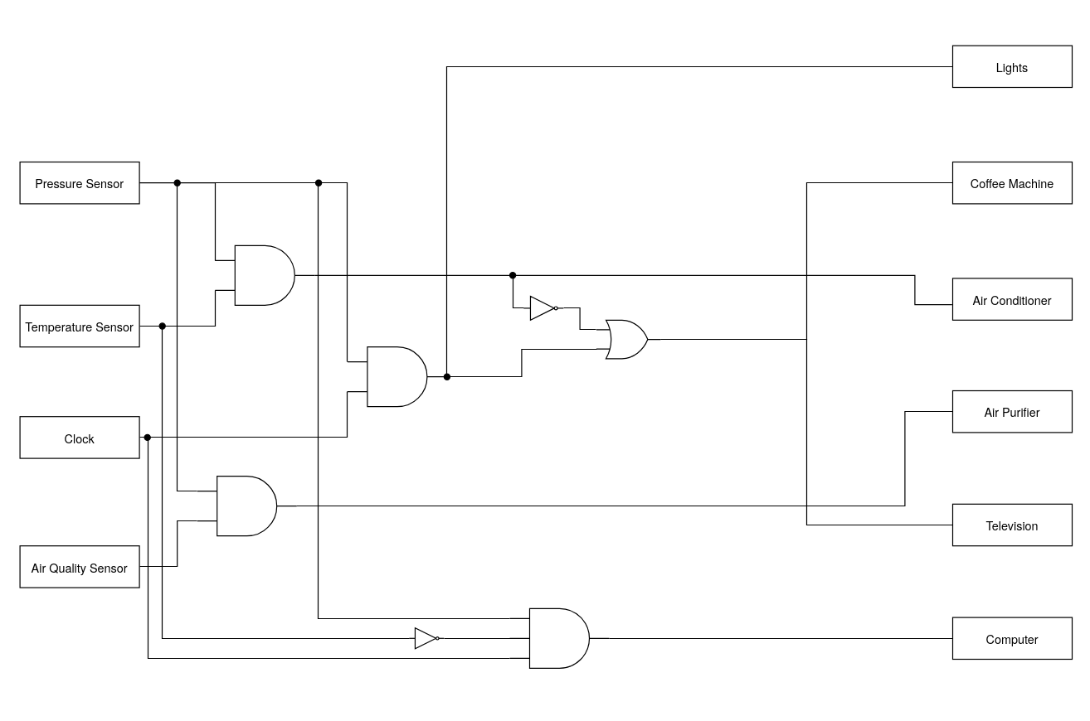
Inputs:
- Pressure Sensor: Used for checking if a person had stepped on the front mat of their front door: 1 means pressured applied and 0 means no pressure
- Temperature Sensor: Used for measuring the temperature outdoors: 1 means temperature is hot and 0 means temperature is not hot
- Clock: Used for checking a specific time: 1 means it is currently evening and 0 means it is not
- Air Quality Sensor: Used for checking the outside air quality: 1 means air quality is at unhealthy levels and 0 means air quality is at healthy levels

Outputs: Lights, Coffee Machine, Air Conditioner, Air Purifier, Television and Computer | 1 means on and 0 means off

Interrupt and Polling in C Programming Assessment

Polling

#include <stdio.h>
#include <termios.h>
#include <unistd.h>
#include <time.h>

int main()
{
clock_t start, end;
double cpu_time_used;

// Set start to current CPU time
start = clock();

int c;
int flag = 0;
int laps = 0;

/*
THIS IS A REPLACEMENT FOR THE _KBHIT FUNCTION
*/
// These structs are for saving tty parameters
static struct termios old_term, new_term;

// Get parameters associated with the tty
// Set the new tty parameters to the old one
tcgetattr(STDIN_FILENO, &old_term);
new_term = old_term;

// Set the new tty parameters to canonical mode
new_term.c_lflag &= ~(ICANON);

// Set tty attributes
tcsetattr(STDIN_FILENO, TCSANOW, &new_term);

// Get character input by user
while ((c = getchar()) != EOF && laps < 10)
{
// Flip the flag
flag = !flag;
laps++;

printf("\n");
printf("Flag: %d\n", flag);
}

// Done retriving input
// Set tty parameters back to old tty parameters
tcsetattr(STDIN_FILENO, TCSANOW, &old_term);

end = clock();
cpu_time_used = ((double) (end - start)) / CLOCKS_PER_SEC;

printf("CPU Time: %f\n", cpu_time_used);

return 0;
}

Explanation

This code is designed for polling keyboard input by routinely checking for user input using the getchar() function in standard C library along with termios.h header functions due to the fact that the kbhit function from the conio.h header file does not exist in the standard C library (glibc). Every time the user hits a key on the keyboard, the flag will switch between 0 and 1, the state will be printed and the program ends when the user hits the 10th key.

The program also includes a clock() function that returns the clock ticks that has elapsed since the program was launched. We assign the start and end variable (start for the clock tick when the program starts and end for the click) and subtract them and divide the result by the CLOCKS_PER_SEC variable which produces the CPU time in seconds of the program.

Results

The program was ran repeatedly 10 times and calculated the average time the polling program took to poll 10 key hits. The results are as follows:

Instance | CPU Time (seconds) | Outlier
1 | 0.000419 | Yes
2 | 0.000380 | No
3 | 0.000372 | No
4 | 0.000393 | No
5 | 0.000374 | No
6 | 0.000371 | No
7 | 0.000341 | No
8 | 0.000420 | Yes
9 | 0.000398 | No
10 | 0.000347 | No
Average | 0.0003815 (Raw) | 0.0002976 (Without Outliers)

Interrupts

#include <stdio.h>
#include <signal.h>
#include <unistd.h>
#include <time.h>

// Declare Variables
int flag = 0;
int lap = 0;

// Handling signal function
void handle_signal(int signal)
{
// If signal is SIGINT
if (signal == SIGINT)
{
// Set flag to its complement
// Print the flag value
flag = !flag;
lap++;
printf("Flag: %d\n", flag);
}
}

int main()
{
clock_t start, end;
double cpu_time_used;

start = clock();

// Handling signal
signal(SIGINT, handle_signal);

// Let the program run until interrupt
while (lap < 10)
{
sleep(1);
}

end = clock();
cpu_time_used = ((double) (end - start)) / CLOCKS_PER_SEC;

printf("CPU Time: %f\n", cpu_time_used);

return 0;
}

Explanation

This program creates an ISR (Interrupt Service Routine) using the signal() function provided by the signal.h header and is used to check for SIGINT signals (Interrupts) which can be sent to the program using the CTRL+C keyboard shortcut. The program checks if the signal passed to the handle_signal function is a SIGINT signal, if so, the program toggles the flag / state and assign to its complement value as well as incrementing the lap variable.

Results

The program was ran repeatedly 10 times and calculated the average time the polling program took to poll 10 key hits. The results are as follows:

Instance | Time Taken (seconds) | Outlier
1 | 0.000367 | No
2 | 0.000422 | Yes
3 | 0.000391 | No
4 | 0.000448 | Yes
5 | 0.000341 | No
6 | 0.000331 | No
7 | 0.000370 | No
8 | 0.000394 | No
9 | 0.000389 | No
10 | 0.000370 | No
Average | 0.0003823 (Raw) | 0.0002953 (Without Outliers)

Comparison

The time taken to run both programs are very similar where the polling program took 0.0002976 seconds and the interrupt program took 0.0002953 seconds with a difference of 0.0000023 seconds or 2.3 µs.

In summary, polling is mostly recommended to be used in context where it is more simple to implement or when working with devices that do not make frequent interrupts, however, has more latency. Interrupts, on the other hand, is mostly recommended to use in context where efficiency is crucial and where its immediate responsiveness is needed for real-time applications.

