Objective
Capture a traffic trace with Wireshark and identify where three End-To-End-Layer techniques appear in the trace, then, interpret one of those techniques in detail using the official protocol standards.

Captured Trace
The trace was captured on the eno1 interface, in this context, the Wi-Fi card; shown in Figure 1.
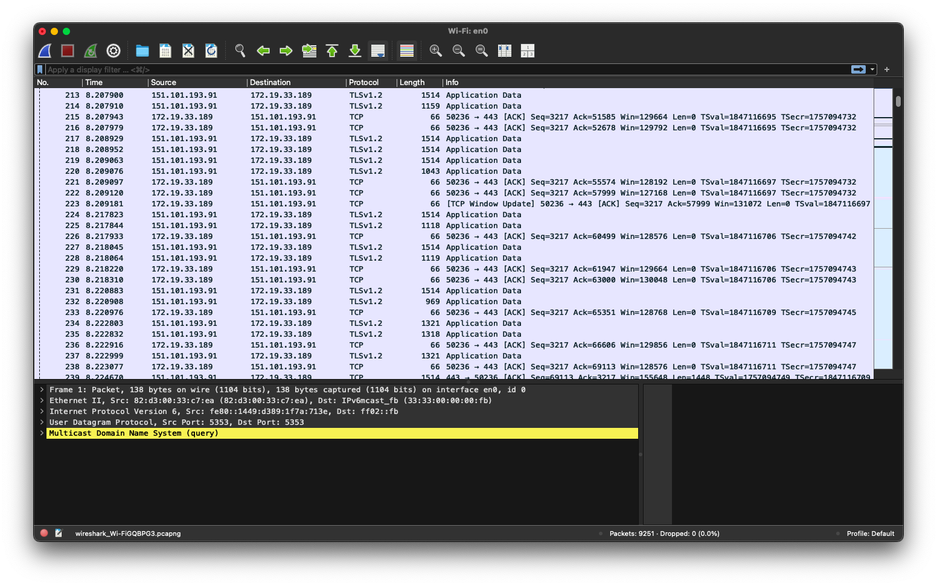Figure 1

End-To-End-Layer Techniques
To demonstrate the different End-To-End-Layer techniques shown in the Wireshark trace, this report will display three different techniques that can be found in this trace.

Connection establishment (TCP three-way handshake)
The Figure 2 shows a filtered Wireshark trace with the filter of tcp.flags.syn == 1 || tcp.flags.fin == 1, this filters packets such as [SYN], [SYN, ACK], ,and [ACK]
The three-way handshake synchronizes sequences numbers (ISS/IRS) and brings the endpoints to the ESTABLISHED TCP state; it prevents old duplicate segments from causing false connections [1].
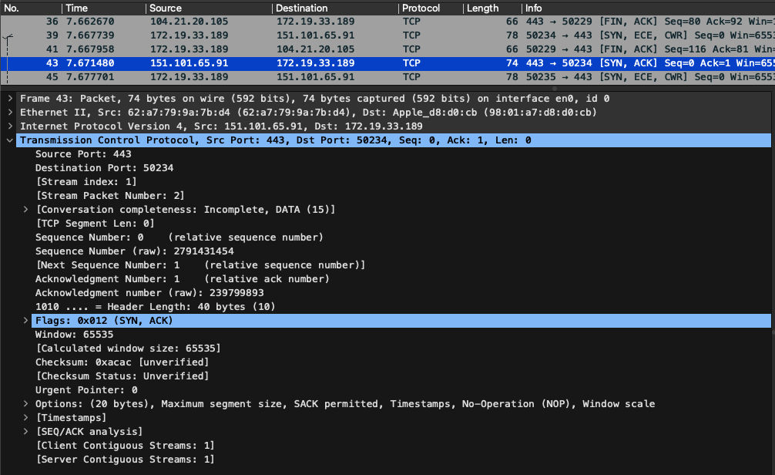Figure 2

Segmentation & Reassembly of long messages
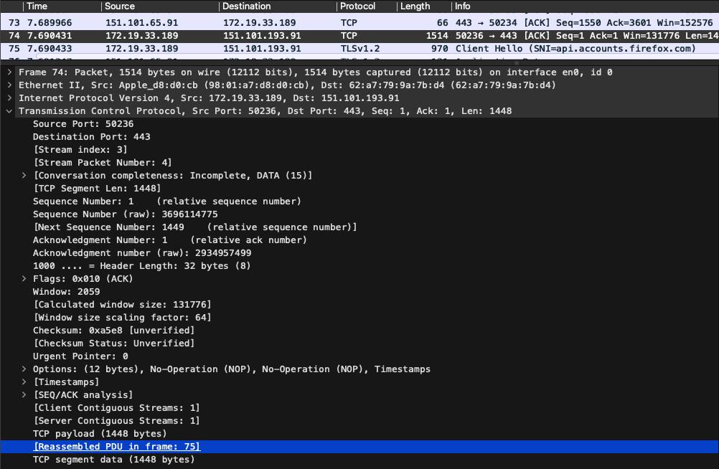Figure 3

Figure 3 displays a reassembled packet, a demonstration of a large application payload across multiple TCP segments because of MSS/MTU limitations. The receiver uses sequences number and the TCP stream to reassemble the contiguous byte stream before delivering it to the higher-level protocol. This is an end-to-end functionality implemented by TCP and used by application protocols which is described in RFC 793 standard [2].

Retransmission (loss recovery to at-least-once delivery behavior)
Figure 4 shows a TCP Retransmission packet, this happens when TCP detects missing ACKs and retransmits the unacknowledged segment to ensure delivery. This provides the reliability property. RFC 973 discusses retransmission expectations and sequence number handling. [3]
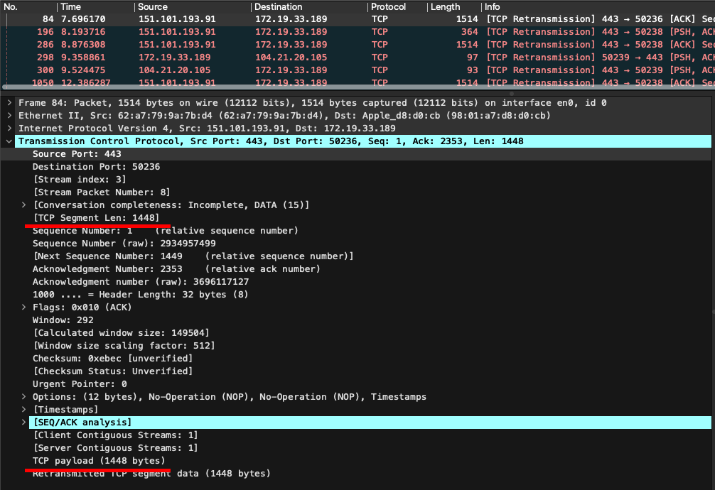Figure 4

References
[1] J. Postel, Transmission Control Protocol, RFC 793, Internet Engineering Task Force (IETF), Sep. 1981. (See §3.4 “Establishing a Connection”, pp. 27–31 for TCP three-way handshake and ISN synchronization.)
[2] J. Postel, User Datagram Protocol, RFC 768, Internet Engineering Task Force (IETF), Aug. 1980. (UDP transport multiplexing description.)
[3] J. Postel, Internet Protocol, RFC 791, IETF, Sep. 1981. (End-to-end fragmentation and reassembly rules — pp. 13–23.)

