- Which of the following sets are well defined? Justify your response in a word or two.
  - The set of football steams.
    - Well defined.
  - The set of integers which are products of two primes.
    - Not well defined.
  - The set of game positions in chess.
    - Not well defined.
  - The set of laws in the USA.
    - Well defined.
  - The set of integers which are the products of at least three different primes.
    - Not well defined.
  - The set of ways a rubic’s cube can be scrambled.
    - Not well defined.
- Find three distinct elements in each of the following sets.
  - 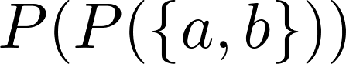
  - 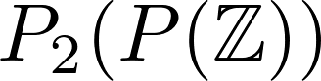
  - 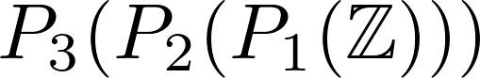
  - 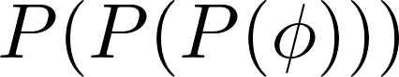
- List all the elements in 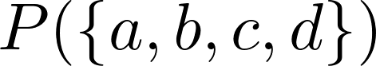
- List all the elements in 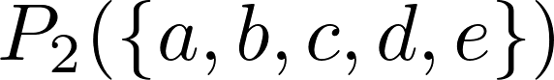
- Write each of the following in set notation, without words if possible:
  - 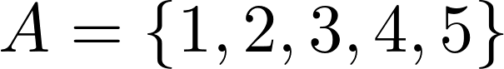
  - 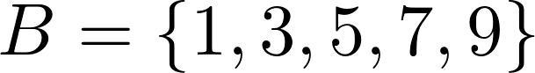
  - 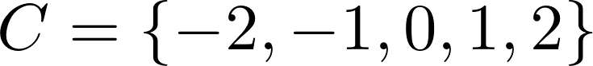
- Which of these sets are equivalent?
- Let and . Are A and B equivalent? Show your work to support your answer.
- Let A be a finite set. Is 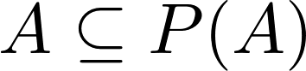 true, false, or cannot tell?

