1.
  X_{n} (Mean) | X̃_{n} (Median)
  5.621 | 5.863
  σ₁ (STD Dev) | σ₂ (MAD) | σ₃ (IQR)
  1.140 | 1.176 | 1.340

2. Maximum likelihood estimators for μ and σ

MLE for μ | MLE for σ
5.621 | 1.135

3. Confidence Intervals provide a range of values that are likely to contain the true mean, proportion or difference between groups with a specific level of confidence or how “good” the estimate is – here, we are calculating the estimate of the mean with a 95% probability.

 | σ₁ | σ₂ | σ₃
X_{n} | (5.431, 5.811) | (5.425, 5.817) | (5.397, 5.844)
X_{n} | (5.625, 6.101) | (5.617, 6.109) | (5.583, 6.143)
These values reveal that when using the sample mean as the estimator for the population mean, the use of different standard deviation estimators had little impact on the resulting confidence intervals, thus, a stable precision.
4. Confidence interval of 95% probability for σ: (1.019, 1.292)

This confidence interval means that, there is a 95% confidence that the true population standard deviation (σ) lies between 1.019 and 1.292.

5.
 | Q₁, Q₂, and IQR: (2.957, 8.210)
   | σ₁ | σ₂ | σ₃
  X_{n} | (3.379, 7.862) | (3.307, 7.935) | (2.985, 8.257)
  X_{n} | (3.617, 8.109) | (3.544, 8.182) | (3.222, 8.504)

The intervals with σ₁ and σ₂ are quite close, suggesting that the different between these two estimators is relatively small, however, the interval with the σ₃ is slightly wider which means that there are more uncertainly in the prediction when this estimator is used – this also applies to the prediction interval for the median. Meanwhile, the IQR provides a robust measure of the spread of the central 50% of the data and here, it shows the range where the middle 50% of the data points will fall, in this case, between the 2.957 (Q1) and 8.210 (Q3).
6.
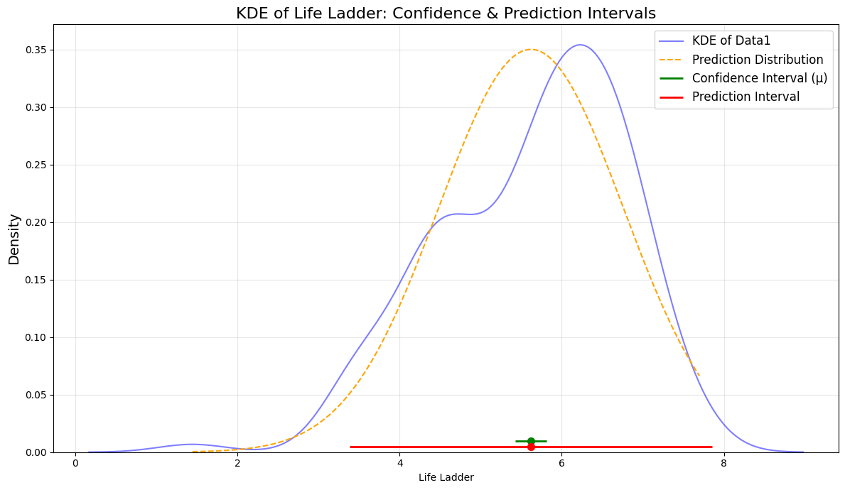
This figure shows the kernel density estimation, the prediction distribution, confidence intervals and the prediction intervals of the variable “Life Ladder”. The KDE represents the density of data at different points and the prediction curve / distribution is the probability of where future observations are likely to fall. In this figure, they have a similar shape but the KDE shifts a bit to the right which says that the density of the data is a bit right from the confidence interval and the prediction interval while the prediction distribution has its peak essentially on the confidence interval and the prediction interval.

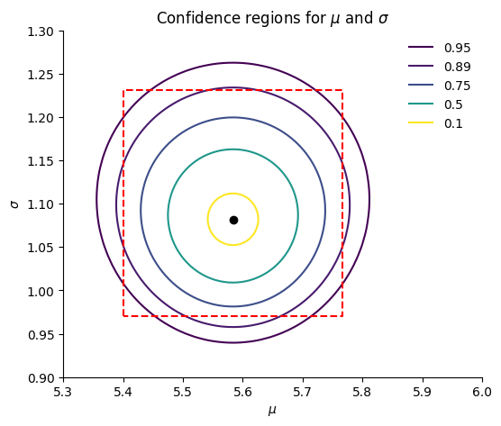
7.
The regions of probability here: 0.1, 0.5, 0.75, 0.89, 0.95 shows the confidence levels – the narrower confidence regions, the less confidence that the true parameters is within the range, however, has a smaller margin or error – meanwhile – a higher confidence level (such as 0.95) represents a greater confidence that the true parameters is within the range but has a larger margin or error.

