Introduction
The purpose of this audit is to assess Chulalongkorn University’s Faculty of Medicine Library’s homepage’s (https://library.md.chula.ac.th/) compliance to the Web Content Accessibility Guidelines (WCAG) introduced by the World Wide Web consortium, widely known as the W3C. As this set of guidelines are the base of various legislation in several countries, such as the USA, France and Australia, related to digital accessibility and universal design, thus, it is highly recommended for organizations and businesses that provide digital products to follow the WCAG standard as not only that the company is complying with the law but also provides products that benefit people with disabilities as well as improving the overall user experience.

Present (In)accessibilities
The website has a feel of a website from the 1990s, however, it contains several design issues as well as accessibility issues, shown in the following section.

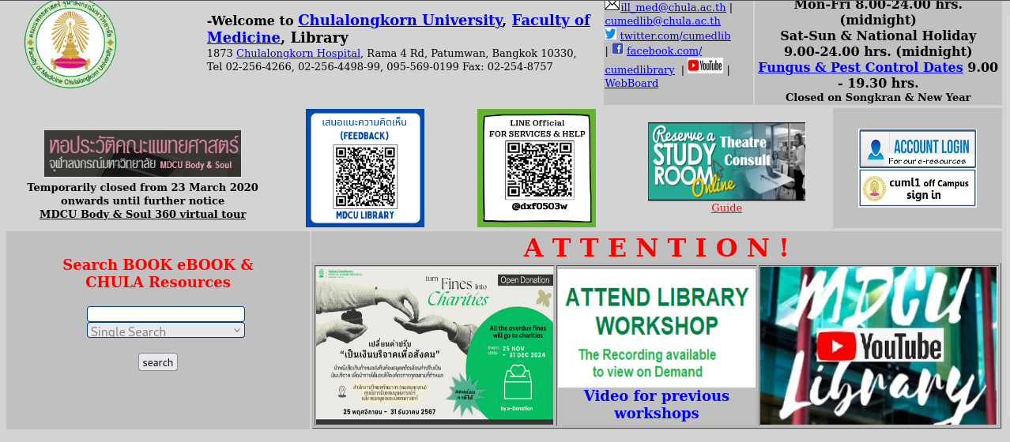
- Navigation - Due to text-based content having similar fonts with to-an-extent clearly defined headings as well as several sections that are not clearly defined such as the search box (see below) with small search box and tiny search button.
- Specific Links or Content – In the topics section of the website, we can see a huge list of blue-colored links, which do not follow the WCAG standard, along with level images that are sized properly according to its aspect ratio, as well as small red texts beside the links that are even harder to read on small screens.
Suspecting that the website creator’s purpose is to document every single category of books or papers inside the faculty’s library, it creates a level of frustration for the user due to the amount of information that is being shown to the user leading them to be overwhelmed with the amount of texts that are being shown on screen, followed by the user not being able to find the resources that they were looking for and potentially leading to the user leaving the website altogether for easier alternatives such as JSTOR, Google Scholar or sci-hub.
(See Images Below)
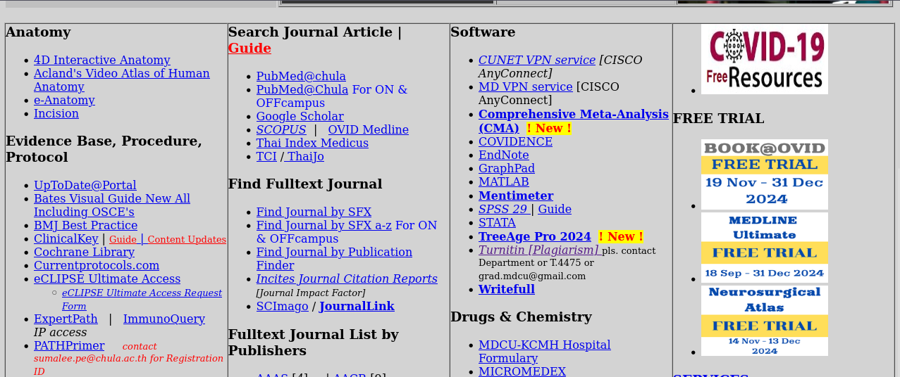
First Section
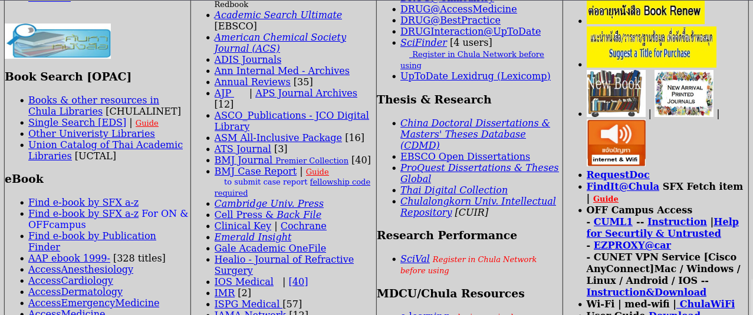
Second Section
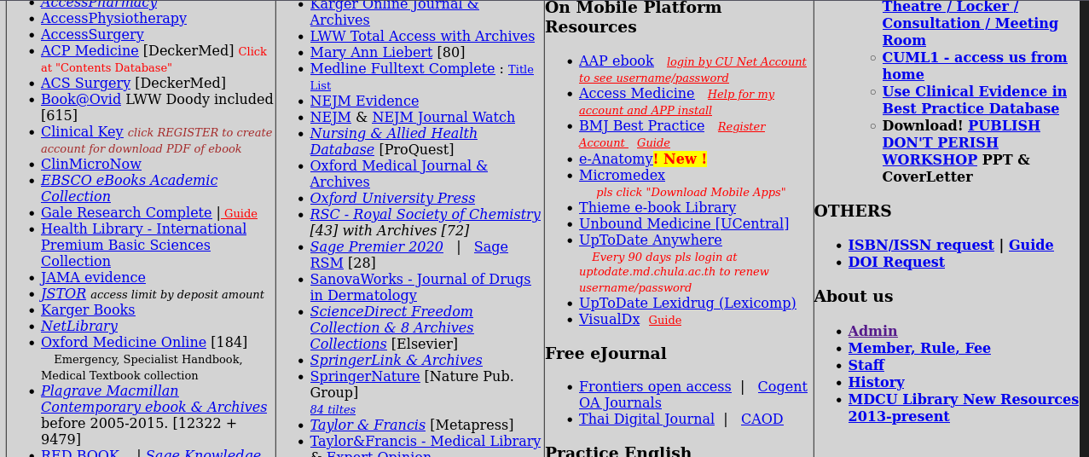
Third Section

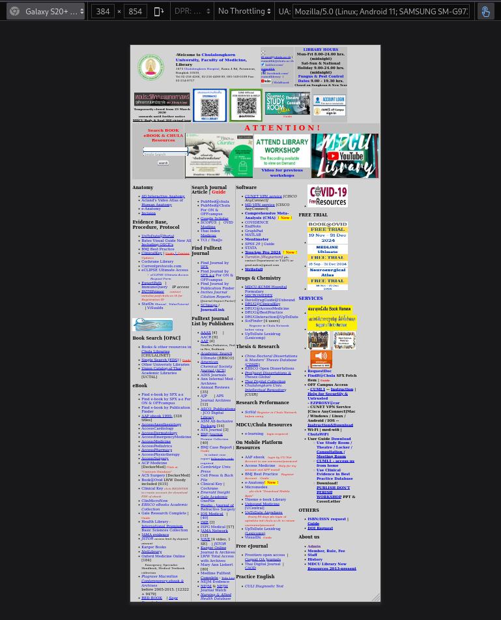
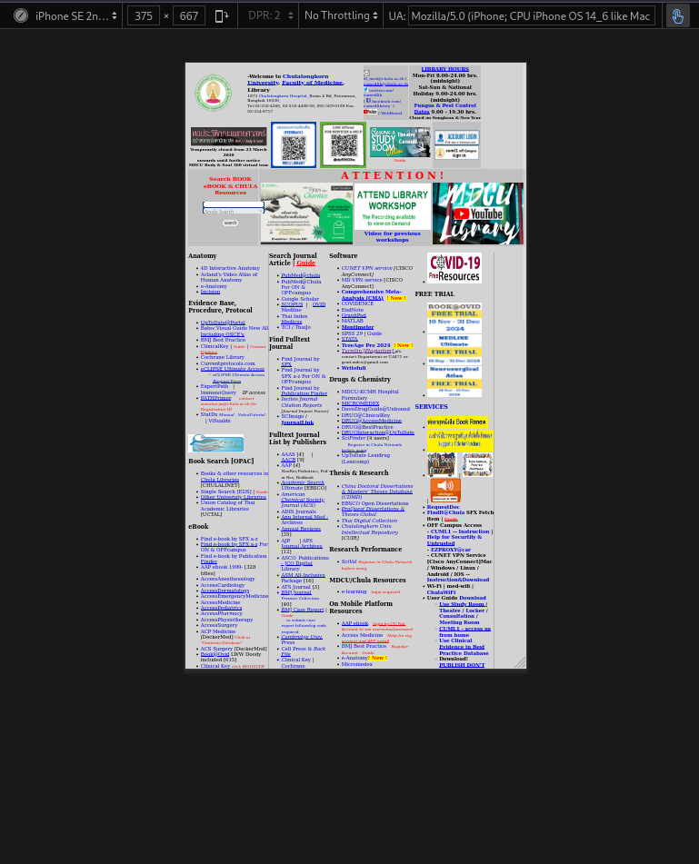
- Mobile Layout Mobile users with small screens are not able to access the full information of the website due to a lack of support for responsive design, such as, small texts, overlapping content, small images – leading to normal users not be able to read what is on the website.

Detailed Audit
A more thorough investigation to the website using the website AccessibilityChecker.org in which it gave the website a 21% rating as well as identified around 300 critical issues when tested with the WCAG 2.2 standard along with three main topics regarding accessibility issues.

- Interaction & Navigation
The audit identified four main issues with the website’s code which affects people with blindness, low vision and immobility.
  - Some elements do not have a label (specifically the search bar shown above).
  - Links are not easily perceptible.
  - The search dropdown element does not contain a name.
  - Elements do not have enough sufficient space and size (for pressing or clicking the element)
Manual checks reveal more issues:
  - Navigation flow is complicated
  - Interactive elements are not easily usable on the small screens
  - Focus indicators do not cover the whole object such as images.
  - There are no available shortcut keys for the website.
- Visual & Structural Accessibility
The audit identified several issues that affect a wide range of people such as people with blindness, low vision, colorblindness and cognitive disabilities.
  - Foreground and background colors do not meet the WCAG 2 (AA) minimum contrast ratio threshold, demonstrated by the colors of the links and backgrounds.
  - Some images do not have alternate text or a role of none (if used for decorative purposes)
  - Tables and Lists are not structured properly (hierarchy of table elements such as th, td and list elements such as ul, li) can lead to screen readers not being able to comprehend the web structure properly.
Manual checks also revealed several issues:
  - Headings are not clear and can be confused with other texts.
  - Tables do not use the <th> element for the headers.
  - Color contrasts does not follow the WCAG standard (images and links)
- Screen Reader & Assistive Touch
The automated audit passing all tests, however, a manual audit was still needed to be checked.
  - Screen readers are able to read the texts but can stumble on several elements such as images due to them not having alternative texts.
  - Focus management is at a moderate level as keyboard navigation is still possible, however, due to the instrumental amount of links, it will take more time to navigate to the information needed.
  - The search bar lacked form labels which causes the screen reader to not be able to tell apart if the text box was a search bar or not, this also applies to other elements that do not have a name attribute as well.

Recommendations and Potential Solutions
From the past two sections, we have observed several issues that both the automated audit and the manual audit has managed to identify, the next step to our audit is to present several recommendations that address the three main categorized issues mentioned in the detailed report.

- Interaction & Navigation
  - Redesign the home page to be less clunky and cluttered; the developer can use an alternative design inspiration for the new design, here are some different approaches:
    - Search Engine-like website where its main purpose is for searching (Google Scholar or JSTOR)
    - News-like website for presenting new academic literature or books in the library (BBC News, Scope.org.uk which follows the WCAG guidelines)
  - Making sure the navigational flow is usable when using keyboards and screen readers
    - Making sure that focus elements are being followed correctly
    - Give search boxes and buttons appropriate space and sizes for clarity
    - Interactive and movable elements can be navigated using accessibility features.

- Visual & Structural Accessibility
  - Ensuring that foreground and background colors follow the WCAG (AA) standard measured from their contrast ratio:
    - Small Text: at least 4.5:1
    - Large Text: at least 3:1
  - Ensuring that the website’s structure is following the HTML standard (table or list elements)
  - Ensuring images include their respective alternative texts along with keeping the images’ aspect ratio or resolution to ensure readability.
- Screen Reader & Assistive Touch
  - To ensure compatibility with screen readers, it is highly recommended to include specific labels or the name attribute for web elements:
    - Text boxes = “Search Box” or “Search”
    - Buttons = “Search button”
    - Dropdown = “Options” or “Search Options”
This helps to differentiate or distinguish different elements better.
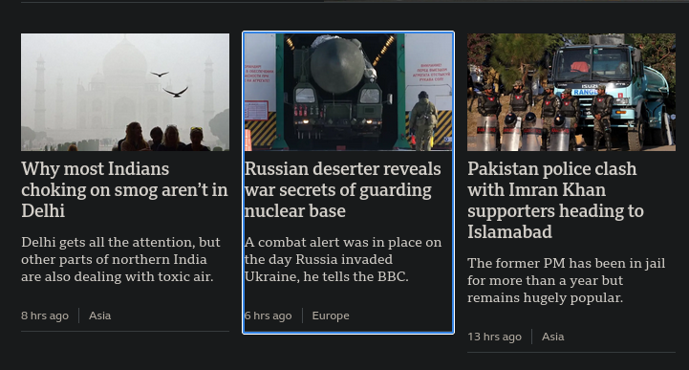
  - Ensure that focus highlights cover the whole element and not a portion of the element, this enhances assistive touch technology as there are a bigger pressing or tapping space for that element (Examples below)
Screenshot from BBC News website, three different elements with the center element being focused.

Summary
In summary, this audit has shown that Chulalongkorn University’s Faculty of Medicine Library’s homepage is in quick need of a redesign, not only to follow the WCAG 2.2 guidelines, but also to keep up with the modern web design standards – the implementation of both of these concepts will absolutely benefit both the web developer and the user. Good user interface results in good user experiences leading to more users coming to visit the website

