Part A – Conceptual Review

Terms | Short Description
OLTP | Shortened of “Online Transaction Processing”; a system designed for managing or processing many real-time transactions.
OLAP | Shortened of “Online Analytical Processing”; a system optimized for performing complex queries or multi-dimensional analytical queries.
Distributed Database | A single database that is distributed across multiple servers, instances or locations.
Cloud Database | A database system provided by cloud provider.
Data Warehouse | A central storage system that keeps structured integrated data from multiple sources.
Data Lake | A central storage system that keeps raw data from many sources.

Part B – Research Task: Real-World Systems

Choose one real-world company or service. Investigate their data management architecture based on public available sources.

Chosen service: Facebook

System Type | Example Technology Used | Purpose | Example Data Managed
OLTP | MyRocks (of MySQL) | Process large amount of queries related to user interactions quickly. | Likes, comments, and shares.
OLAP | Scuba, Scribe | Process large amount of logs and turning them into analytical reports. | Logs of events
Distributed Database | MyRocks / MySQL | Storing various types of data; user interactions, profiles, posts, and so on. | User profiles, images, videos, text messages, etc.
Data Warehouse | Hive | Creating reports, analytics, or dashboards. | Users, ad clicks, sales reports.
Data Lake | Hadoop | Storage of raw and curated data along with machine learning and data exploration. | Raw logs, JSON events, images, videos, posts.

Part C – Concept Integration Task

Chosen organization: Facebook

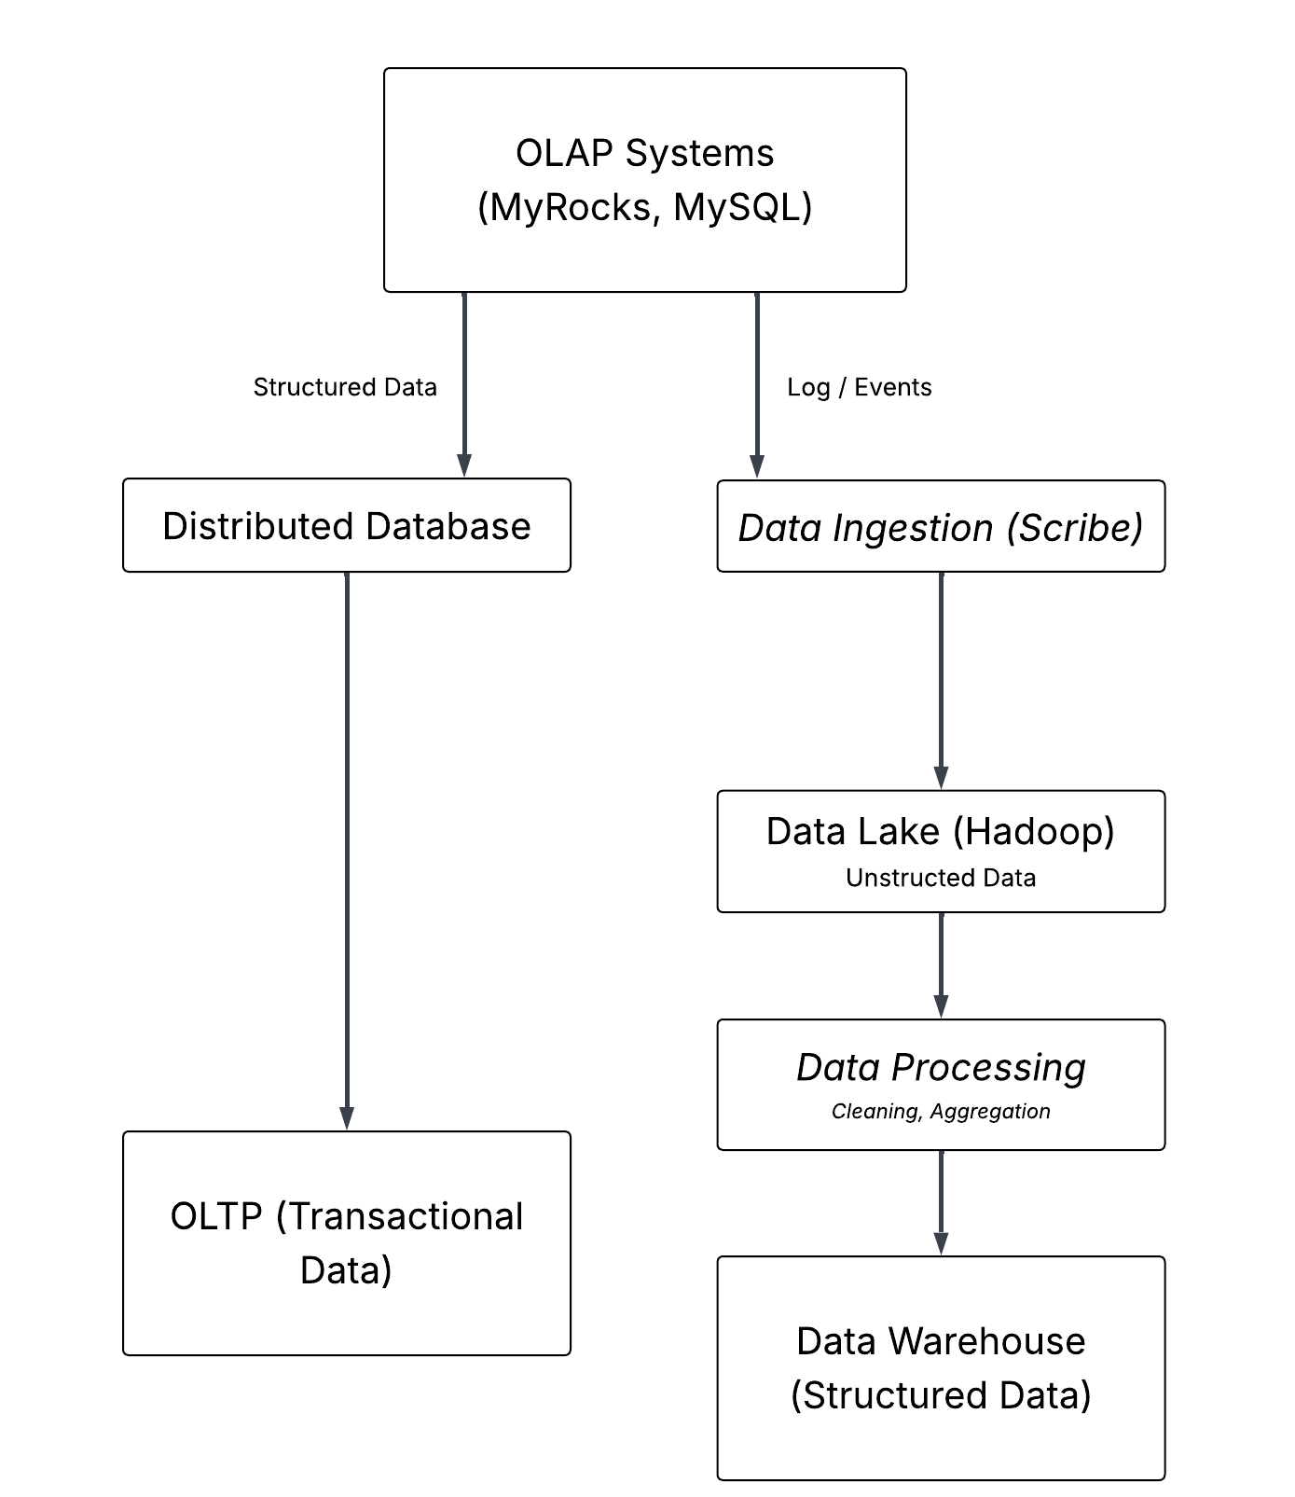
Part D – Case-Based Application

Chosen business scenario: Huge book store

- What data would be stored in the OLTP system?
The data that would be stored in this supposed system are such as, book purchases, customer requests, reviews, etc.
- What analytical questions would be answered by the OLAP or Data Warehouse?
In this context, questions such as, “What is the most popular book during June 2025?”, “What is the most popular genre”, “How are the overall reviews of this specific book?”, “Overall customer satisfaction?”
These questions are ones that are related to the statistics / analytics of data and they can be answered using OLAP systems or Data Warehouses.
- What kind of data (raw logs, media files, etc.) would go into a Data Lake?
The raw data lake would be storing files such as, book cover images, profile pictures, catalogs of books, PDFs of e-Books, raw JSON book description or format files, and so on.
- Which parts of your design could benefit from cloud or distributed databases?
Cloud or distributed databases would greatly benefit the Data Lake and the Data Warehouse, since these will most likely be built on top existing relational database solutions along with how said databases will be needed to scale as the system enlarges.

Part E – Reflection

- What are the main differences between OLTP and OLAP systems in terms of design and performance?
- Why are Data Warehouses still used when Data Lakes exist?
- How does distribution and cloud deployment improve database reliability and scalability?
- If you were designing your own startup’s system, which combination would you choose — and why?

