- Wireshark
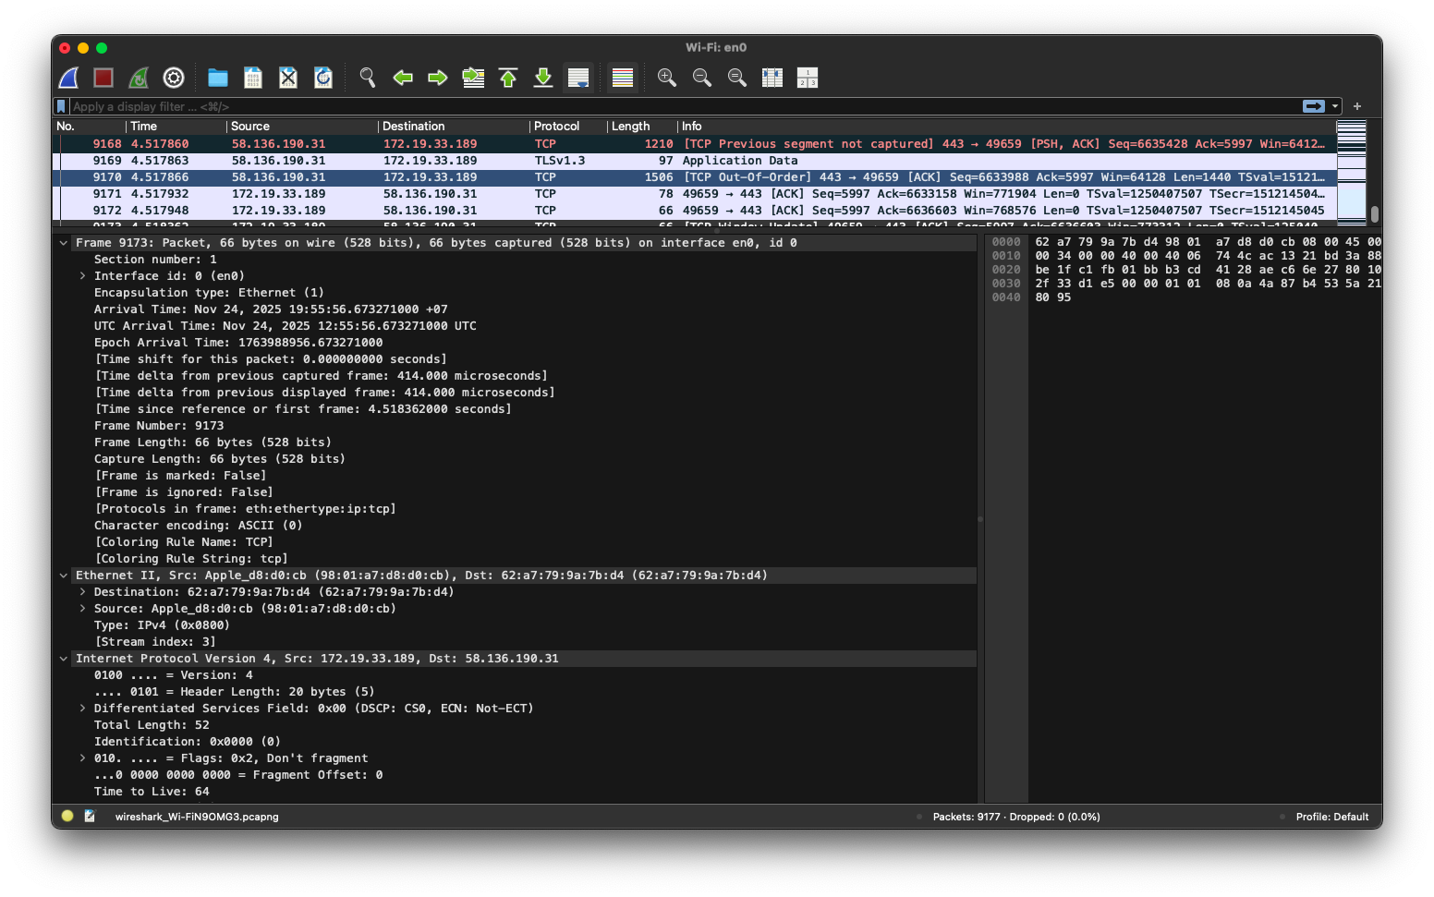
  - Capture & Show a traffic trace
  - Show three Link-Layer techniques.
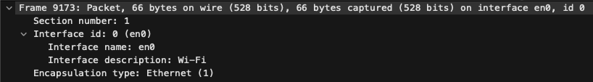
    - Framing
Framing is shown here under the Ethernet II section
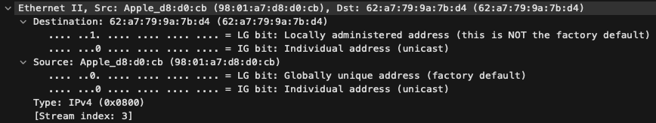
    - Multiplexing
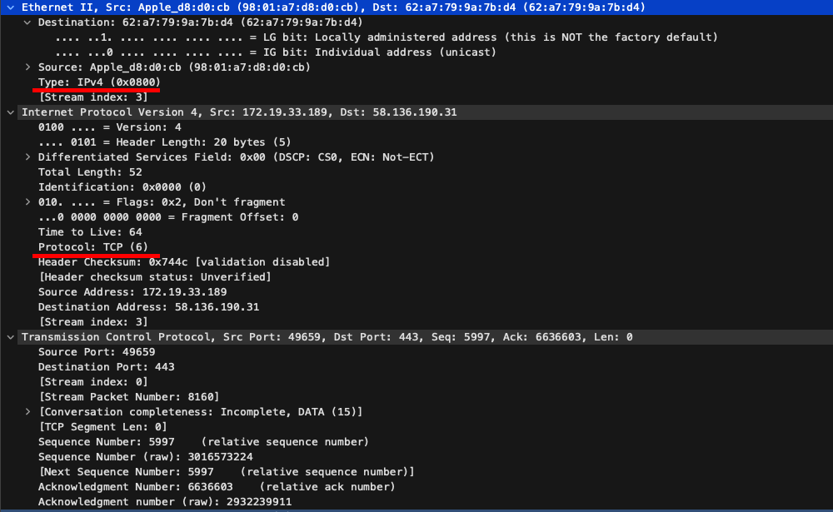
    - Network-layer interfacing
- Referring to protocol standards…
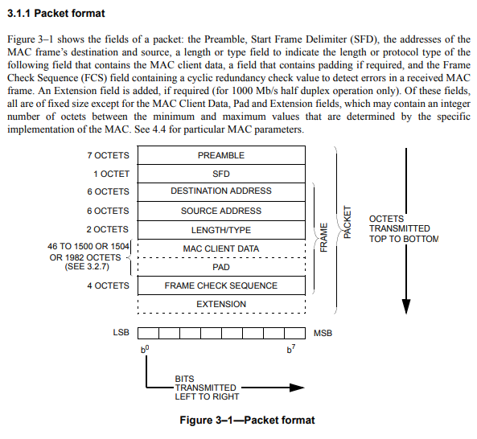
  - Examine one Link-Layer techniques
The Framing Link-Layer technique seen in the Wireshark “Frame” section is defined in the IEEE 802.3-2022 standard, in which, defines the frame format e.g. destination and source addresses, length/type field, data/payload, and frame check sequences (FCS).

