Part A – Conceptual Review

Terms | Short Description
OLTP | Shortened of “Online Transaction Processing”; a system designed for managing or processing many real-time transactions.
OLAP | Shortened of “Online Analytical Processing”; a system optimized for performing complex queries or multi-dimensional analytical queries.
Distributed Database | A single database that is distributed across multiple servers, instances or locations.
Cloud Database | A database system provided by cloud provider.
Data Warehouse | A central storage system that keeps structured integrated data from multiple sources.
Data Lake | A central storage system that keeps raw data from many sources.

Part B – Research Task: Real-World Systems

Choose one real-world company or service. Investigate their data management architecture based on public available sources.

Chosen service: Facebook

System Type | Example Technology Used | Purpose | Example Data Managed
OLTP | MyRocks (of MySQL) | Process large amount of queries related to user interactions quickly. | Likes, comments, and shares.
OLAP | Scuba, Scribe | Process large amount of logs and turning them into analytical reports. | Logs of events
Distributed Database | MyRocks / MySQL | Storing various types of data; user interactions, profiles, posts, and so on. | User profiles, images, videos, text messages, etc.
Data Warehouse | Hive | Creating reports, analytics, or dashboards. | Users, ad clicks, sales reports.
Data Lake | Hadoop | Storage of raw and curated data along with machine learning and data exploration. | Raw logs, JSON events, images, videos, posts.

Part C – Concept Integration Task

Chosen organization: Facebook

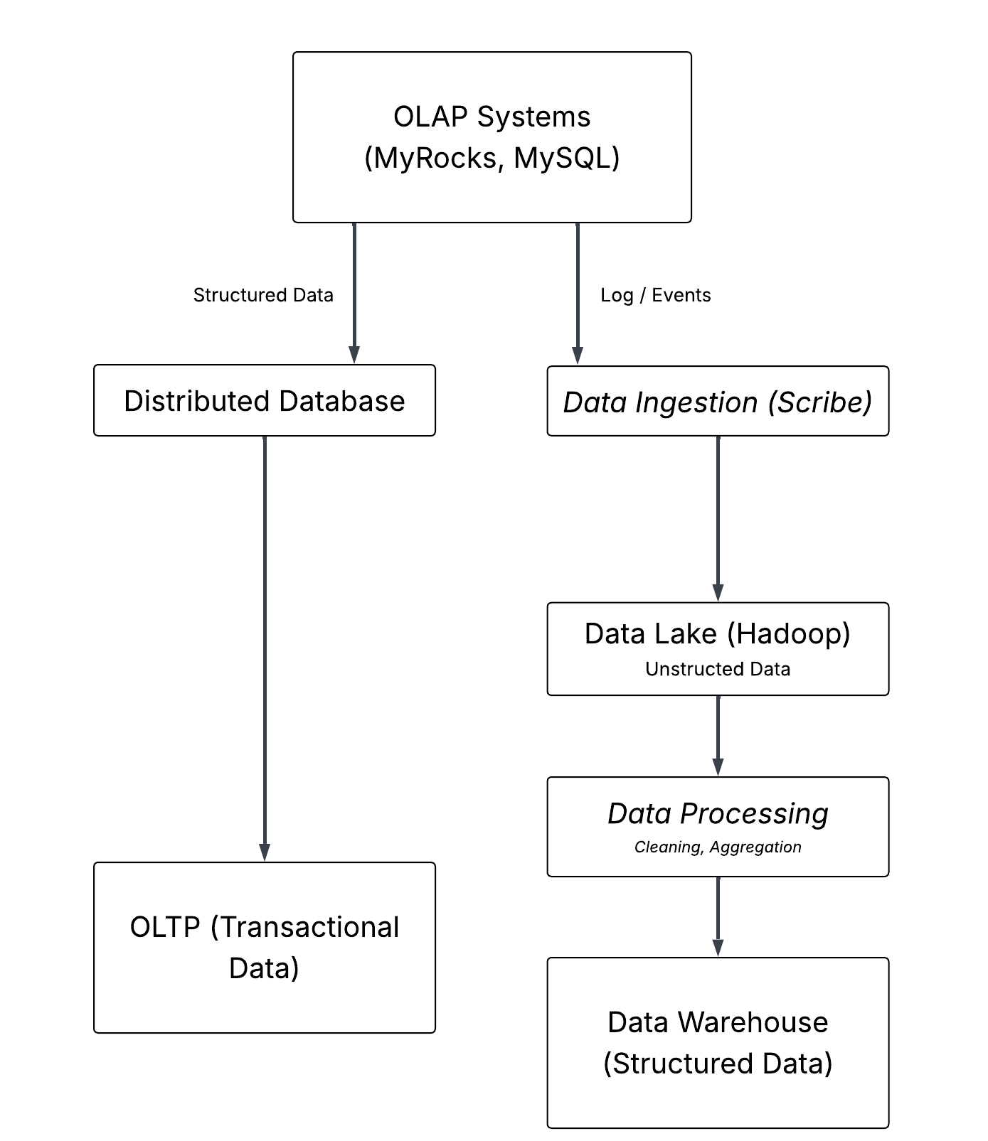
Part D – Case-Based Application

Part E – Reflection

