Part A: MongoDB Setup Instructions

1. Installation of MongoDB Community Edition
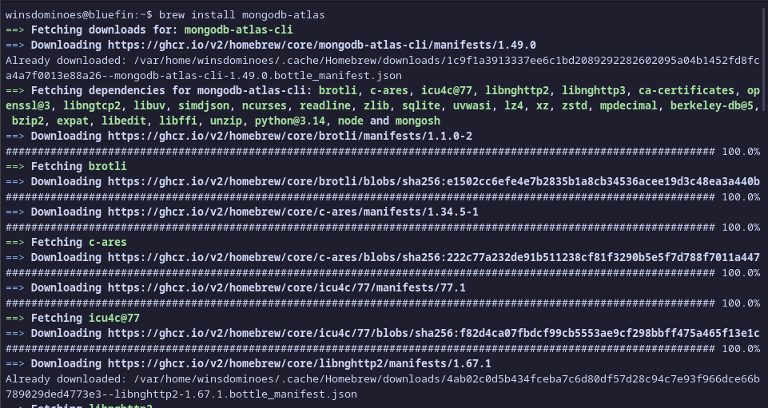
2. MongoDB Compass Installation (Installed via Flathub for Linux)

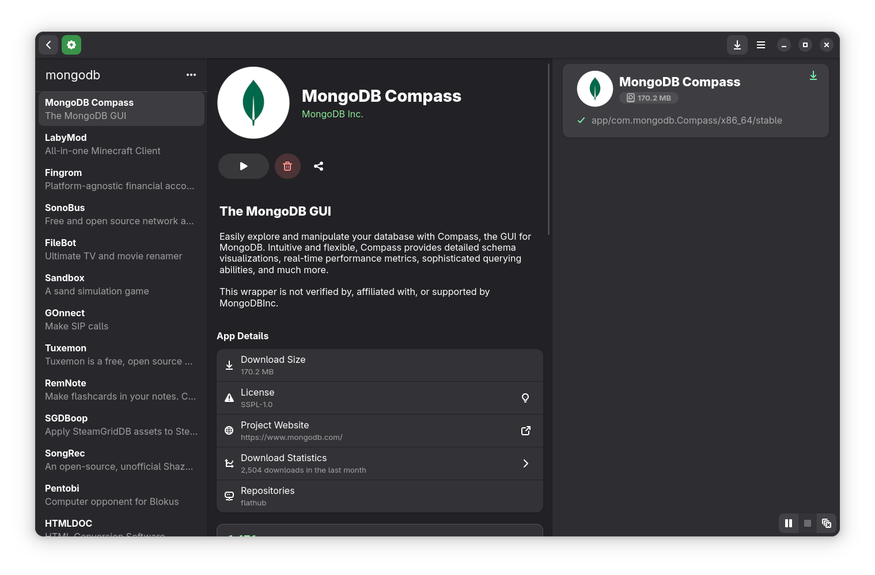 | 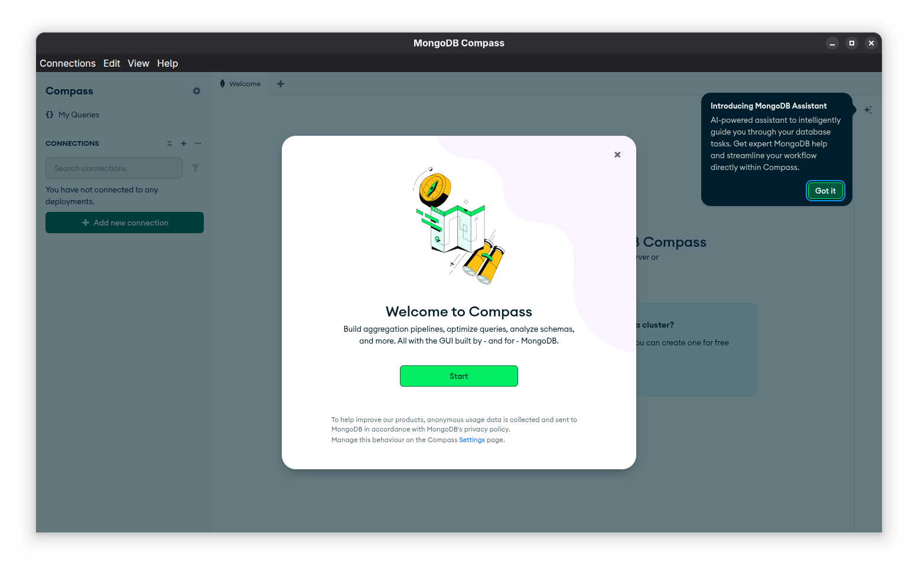

3. Download the Sample Airbnb Dataset

I. Download the JSON dataset from MongoDB

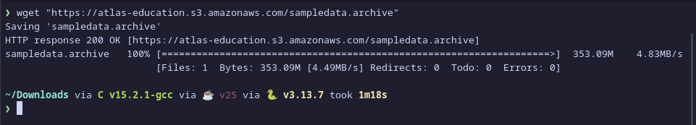
II. Install MongoDB Command Line Database Tools

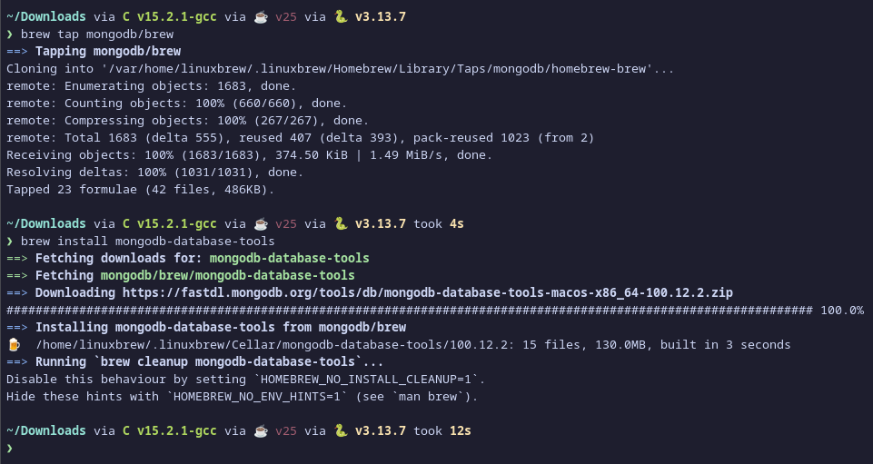
III.

Part B:

