Original Query | Optimized Query
EXPLAIN ANALYZE SELECT r.rental_id, r.rental_date, c.first_name, c.last_name  FROM rental r  JOIN customer c ON r.customer_id = c.customer_id  WHERE c.last_name = 'Miller';  Results  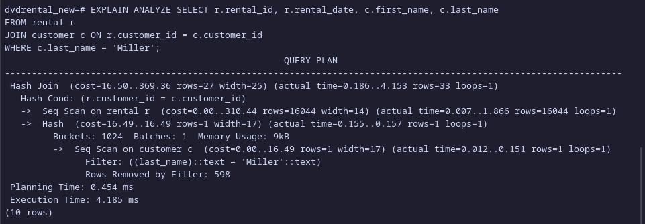  Execution Time: 4.185 ms | Same query as the original but includes two more indexes:  - idx_basic_customer_lastname  Results  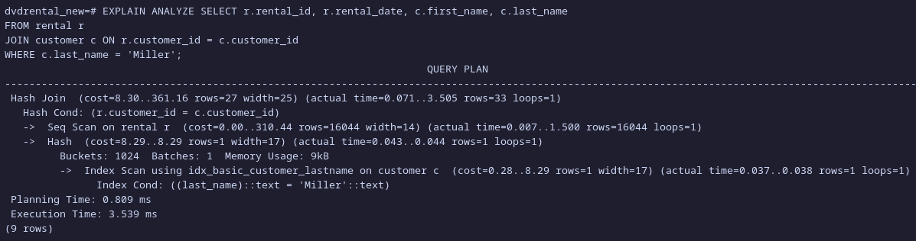  Execution Time: 3.539 ms
The index idx_basic_customer_lastname reduce the execution time as there is less data needed to be fetched from the customer table.
EXPLAIN ANALYZE SELECT f.title, COUNT(r.rental_id) AS rental_count  FROM film f  JOIN inventory i ON f.film_id = i.film_id  JOIN rental r ON i.inventory_id = r.inventory_id  GROUP BY f.title  ORDER BY rental_count DESC  LIMIT 10;  Results  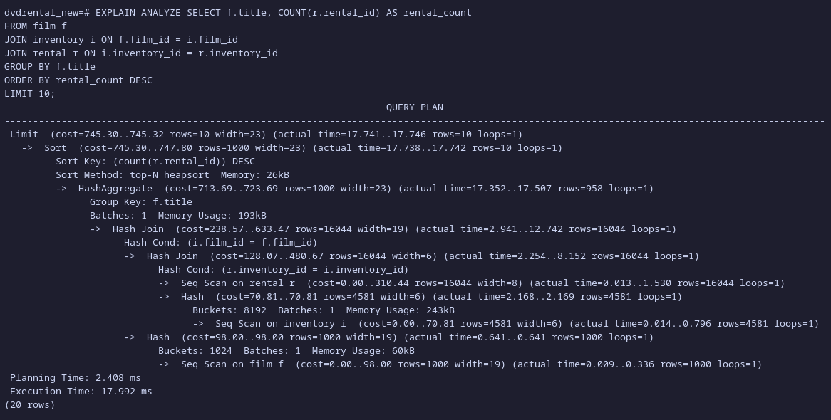  Execution Time: 17.992 ms | Same query as the original but with extra indexes:  - idx_film_data  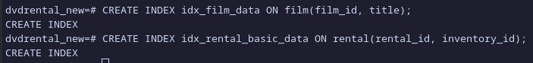  - idx_basic_rental_data  Results  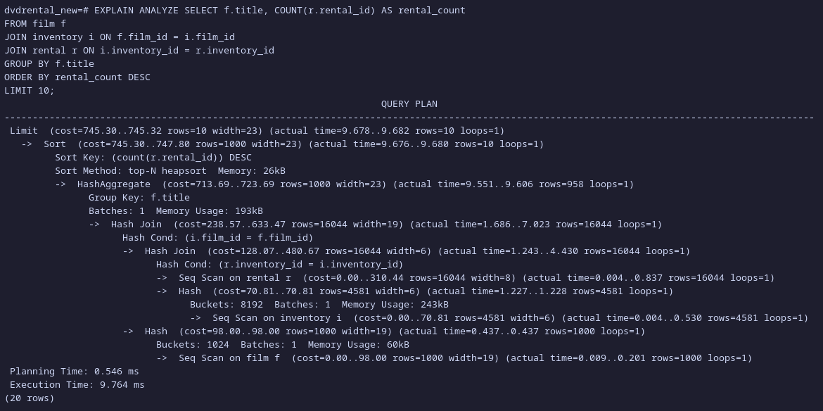  Execution Time: 9.764 ms
The two additional indexes, again, perform the actions in which it reduces the amount of data needed to be fetched from the two tables, rental & film.

EXPLAIN ANALYZE SELECT c.city, SUM(p.amount) AS total_revenue  FROM city c  JOIN address a ON c.city_id = a.city_id  JOIN customer cu ON cu.address_id = a.address_id  JOIN payment p ON cu.customer_id = p.customer_id  GROUP BY c.city  ORDER BY total_revenue DESC;  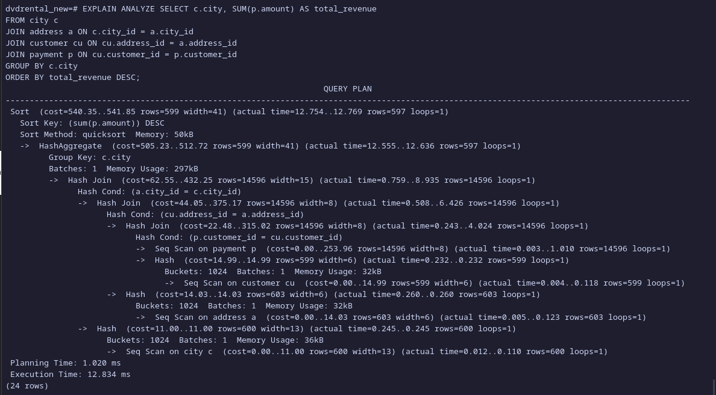  Results:  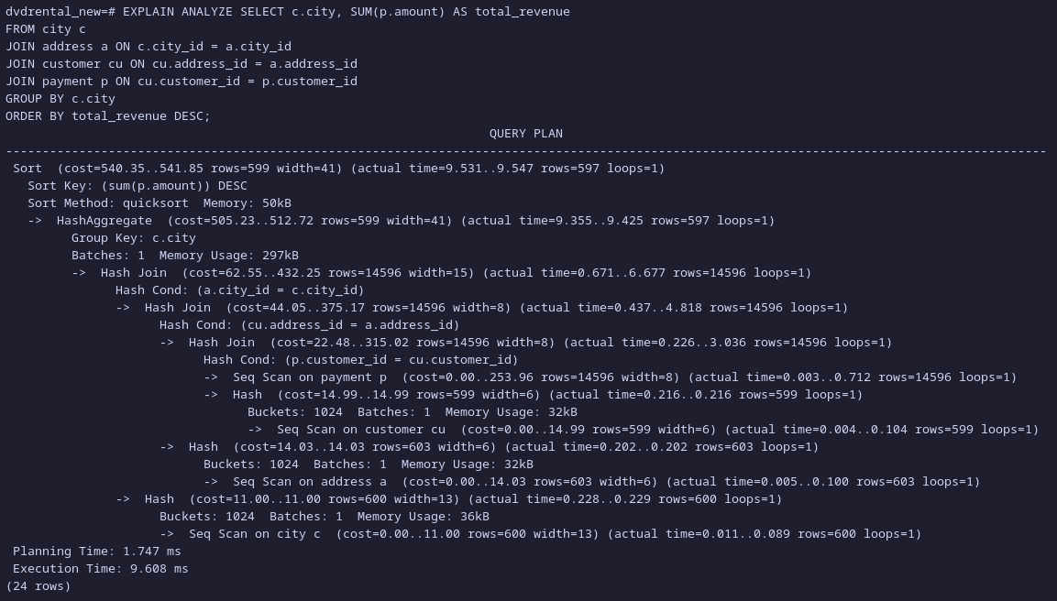  Execution Time: 12.834 ms | The same exact query but with additional indexes: city, payment, address and customer.  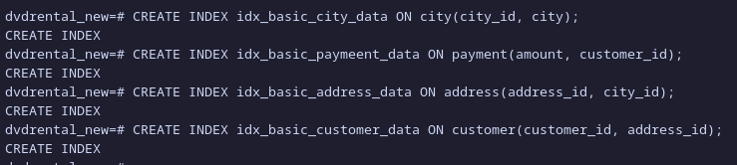  Results:  Execution Time: 9.608 ms

Part B: Query Rewrite Challenge

Original Query | Optimized Query
SELECT * FROM film  WHERE film_id IN (  SELECT film_id FROM inventory WHERE store_id = 1);  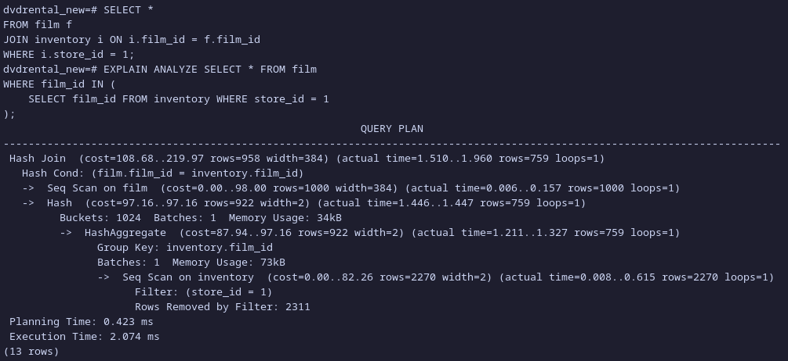  Execution Time: 2.074 ms | SELECT *  FROM film f  INNER JOIN inventory i ON i.film_id = f.film_id  WHERE i.store_id = 1;  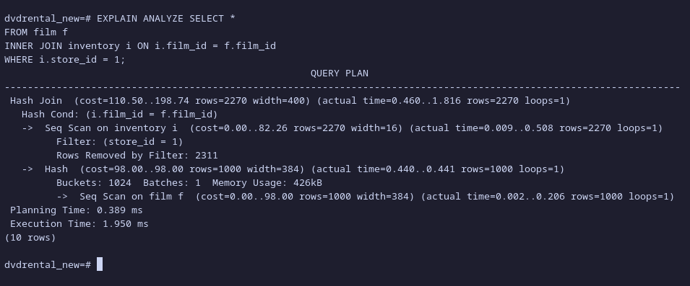  Execution Time: 1.950 ms
The re-written version may seem to have a minimal impact, though, moving from a sub-query to a join is more fast & efficient since sub-queries execute once for each row in the main query while JOINs execute once for the main query.

SELECT * FROM customer WHERE LOWER(last_name) = 'smith';  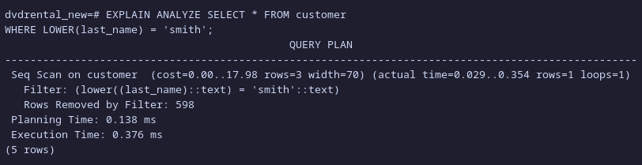  Execution Time: 0.376 | SELECT * FROM customer  WHERE last_name ILIKE 'smith';  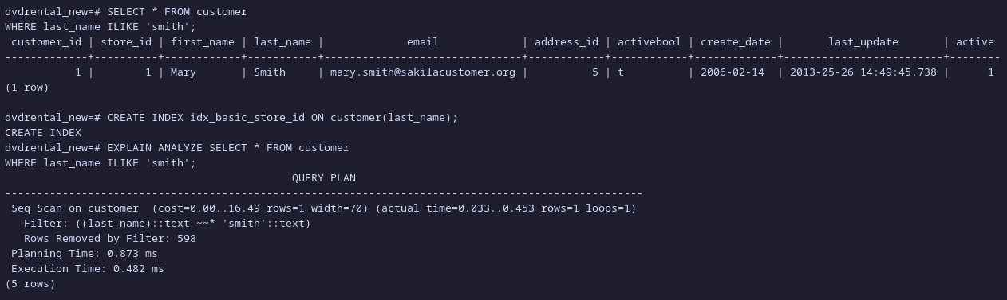  Execution Time: 0.482
The image on the left shows a longer execution time even after adding the index and re-writting the query, however, in a larger scale, the queries would be faster and more efficient.

Part C: Experiment – Index Trade-offs

1. Measure the runtime of inserting 5,000 rows into a new table without indexes.

CREATE TABLE test_insert (id SERIAL PRIMARY KEY, data TEXT);
INSERT INTO test_insert (data)
SELECT md5(random()::text) FROM generate_series(1,5000);

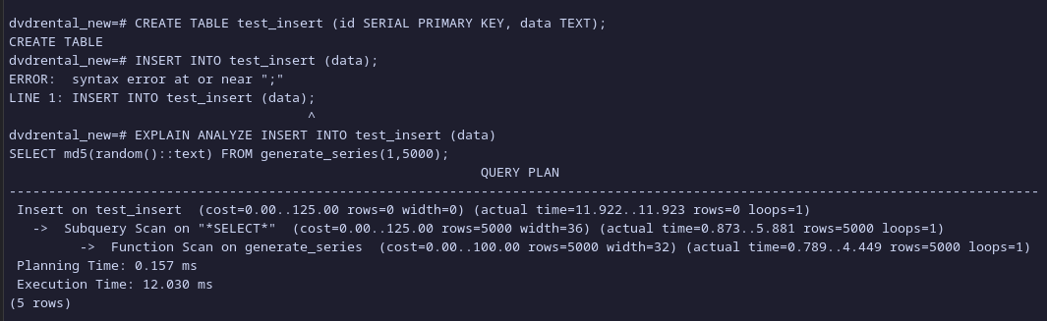
2. Add an index:

CREATE INDEX idx_data ON test_insert(data);

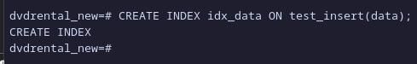

3. Insert another 5,000 rows. Compare runtimes.

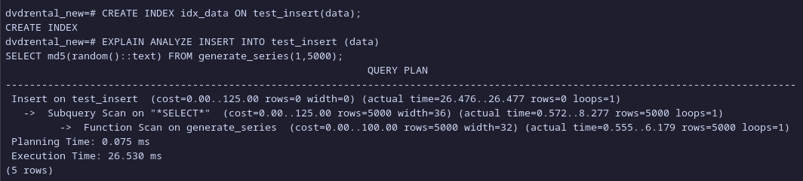
It seems like the execution time doubled, this is due to the fact that indexes require more storage space and therefore requires more data to be written and logged.

Part D: Open Problem

Initial Query:
SELECT C.customer_id, C.first_name, C.last_name, F.title
FROM rental R
INNER JOIN customer C ON C.customer_id = R.customer_id
INNER JOIN inventory I ON I.inventory_id = R.inventory_id
INNER JOIN film F ON F.film_id = I.film_id
ORDER BY C.customer_id DESC
LIMIT 100;

1. Propose an indexing strategy.

The indexing strategy mainly group up columns in each table into composite indexes. For instance: customer_id, first_name, last_name → idx_customer_data.

The full indexes are shown below.

CREATE INDEX idx_customer_data ON customer(customer_id, first_name, last_name);
CREATE INDEX idx_inventory_data on inventory(inventory_id, film_id);
CREATE INDEX idx_rental_data on rental(customer_id, inventory_id);

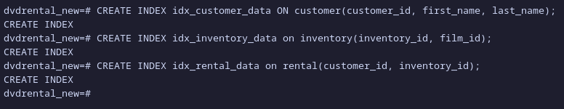
2. Show execution plan before and after.

Before Indexing

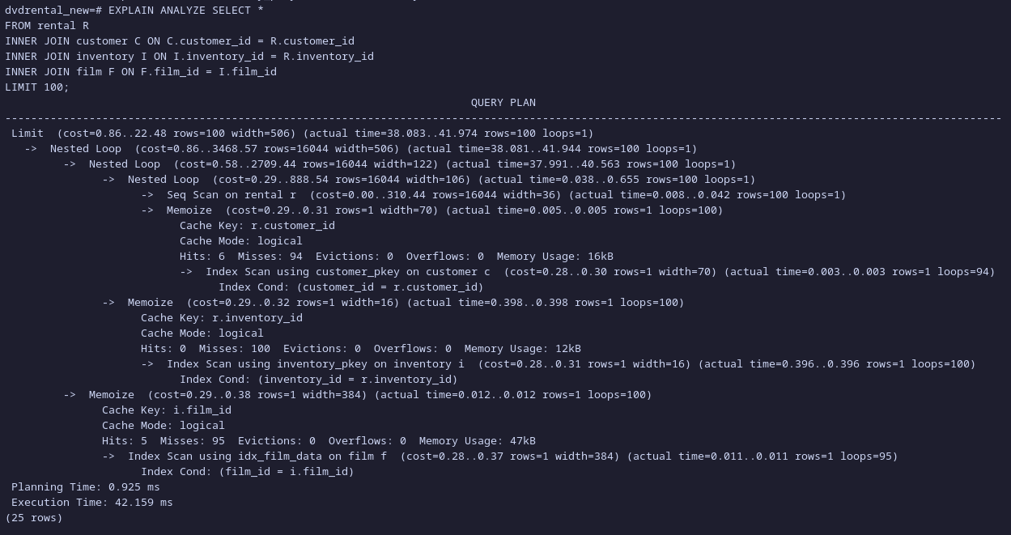
After Indexing

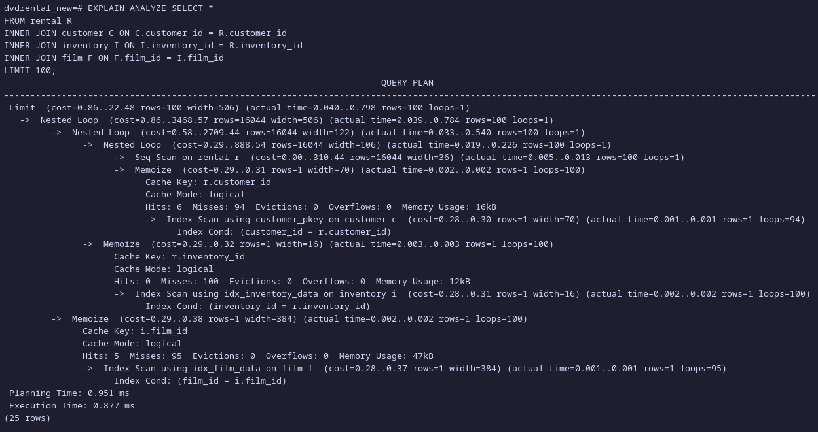
3. Explain how your index improved performance.

We can see that the execution time decreased significantly from 42 ms to 0.87 ms, this is due to the fact that the indexes that were creased reduced the amount of the data that has to be selected from each table into ones that are actually required by the query, as a consequence, it helps the database to be able to locate and access rows quicker.

