ER Diagram

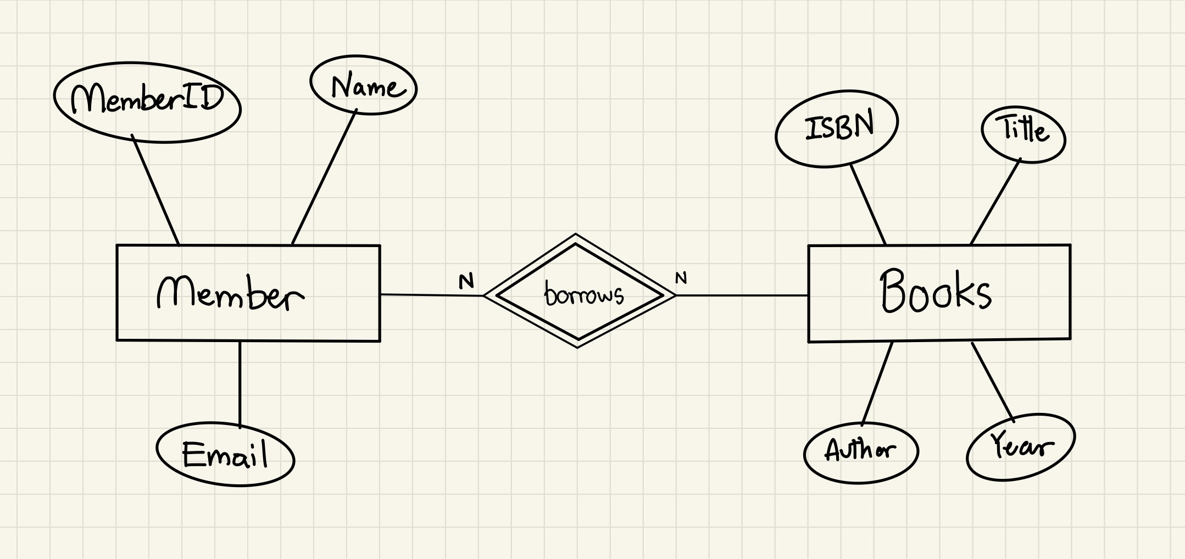
Relational Schema

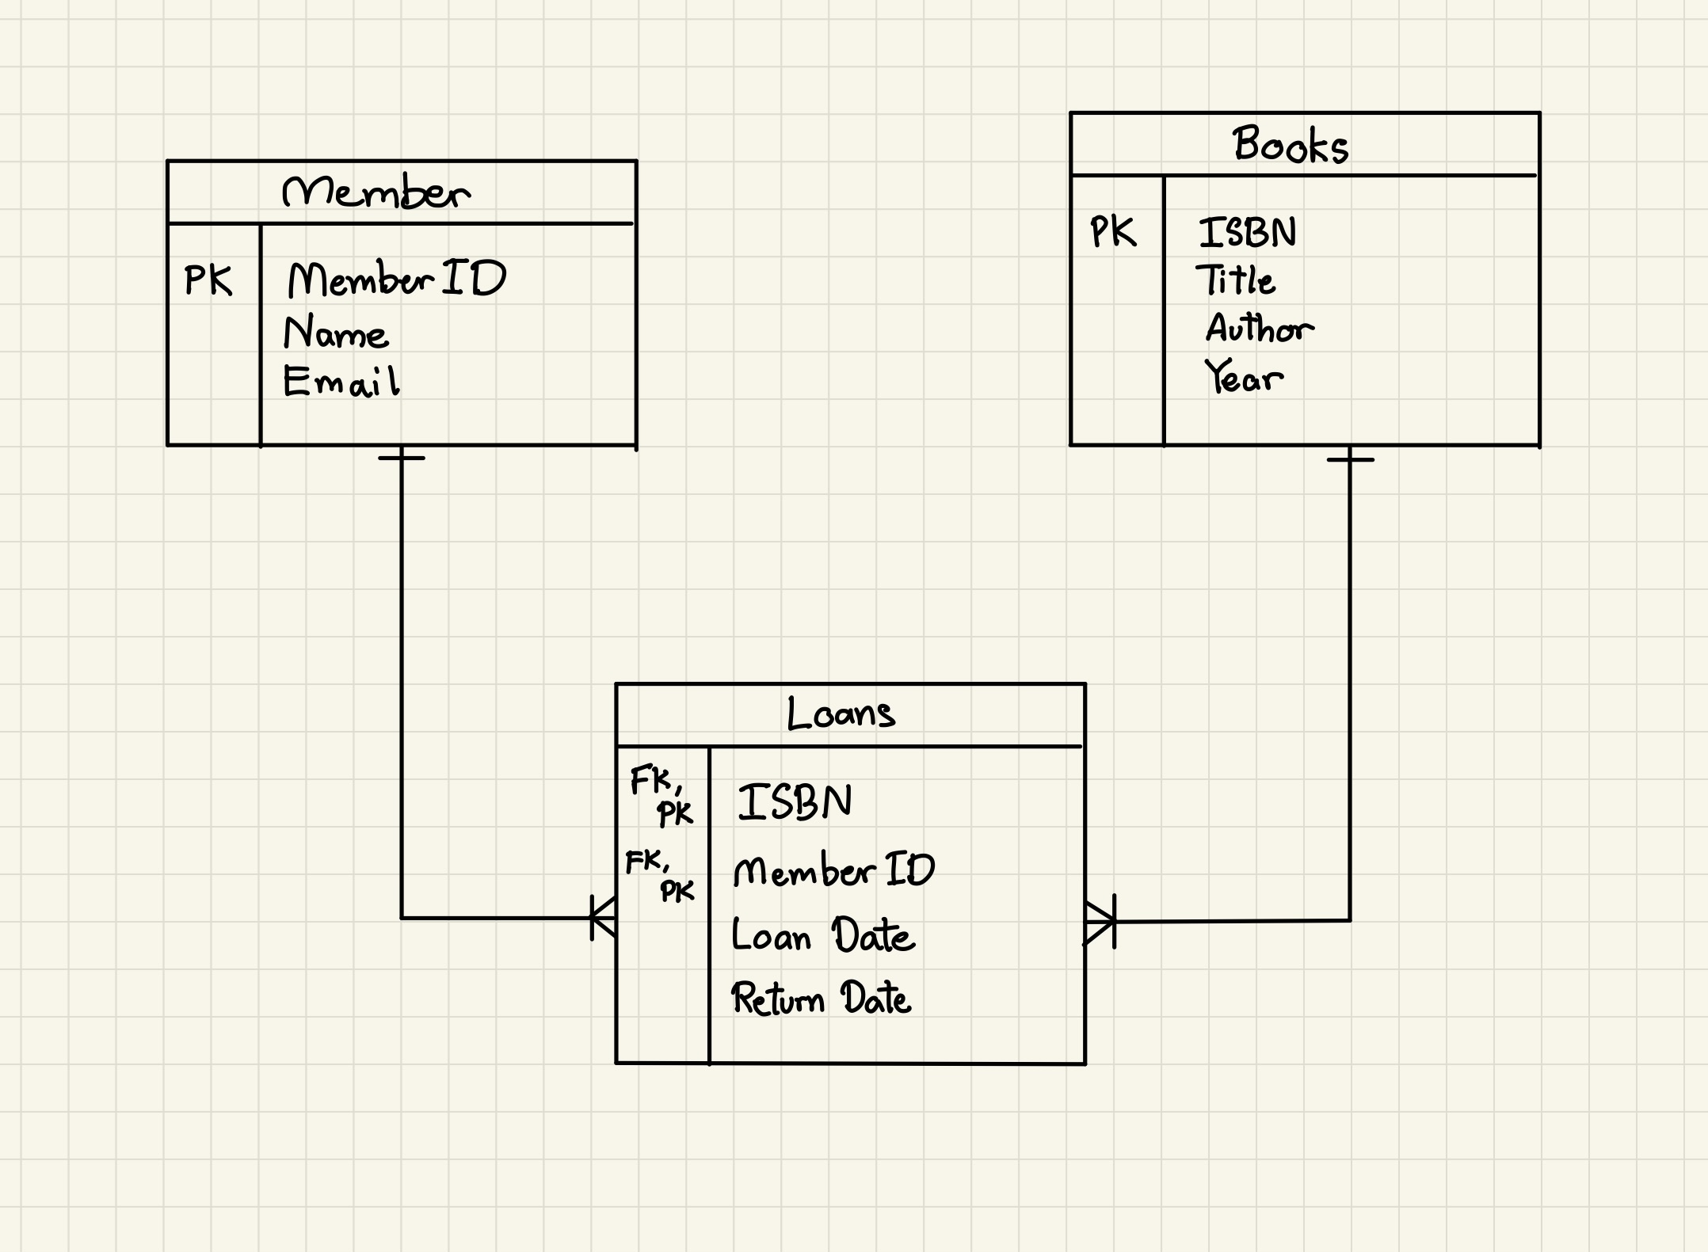

SQL Queries

SQL Query | Output
CREATE DATABASE library;  CREATE TABLE book (  isbn BIGINT PRIMARY KEY,  title VARCHAR(50) NOT NULL,  author VARCHAR(50) NOT NULL,  year INT NOT NULL  );  CREATE TABLE member (  member_id INT PRIMARY KEY,  name VARCHAR(50),  email VARCHAR(50) NOT NULL  );  CREATE TABLE loan (  isbn BIGINT REFERENCES book(isbn),  member_id INT REFERENCES member(member_id),  loan_date DATE NOT NULL,  return_date DATE NOT NULL,  PRIMARY KEY(isbn, member_id)  ); | 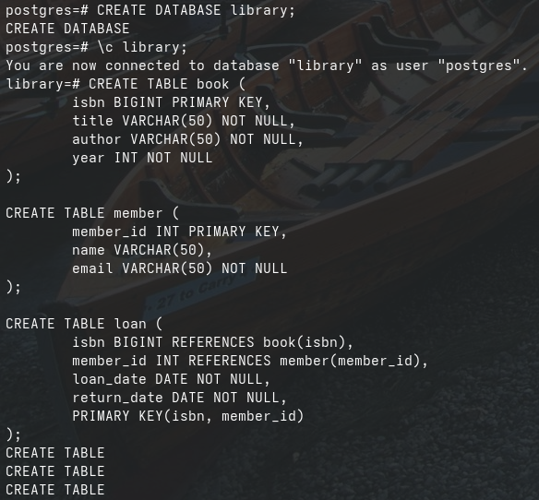
INSERT INTO book VALUES  (9781927077030, 'The Three Principles of the People - San Min Chu I', 'Sun Yat-Sen', 2011),  (9780717802418, 'The Communist Manifesto', 'Karl Marx, Friedrich Engels', 1848),  (9780131103627, 'C Programming Language, 2nd Edition', 'Brian W. Kernighan, Dennis M. Ritchie', 1988);  INSERT INTO member VALUES  (10000001, 'Winnie The Pooh', 'winniethepooh@gmail.com'),  (10000002, 'Gary the Dinosaur', 'garythedino@gmail.com');  SELECT * FROM book;  SELECT * FROM member; | 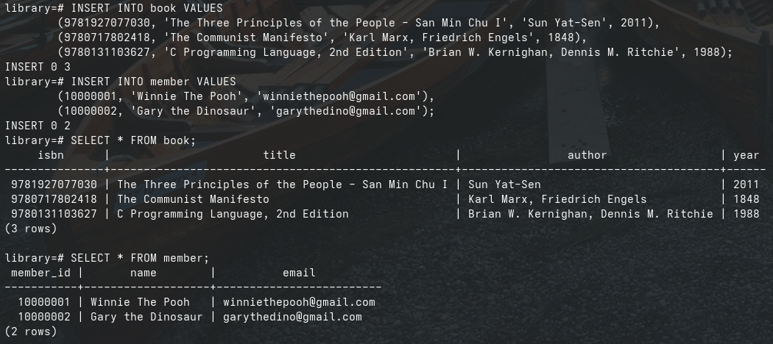
INSERT INTO loan VALUES  (9780131103627, 10000001, '2025-09-11', '2025-09-14'),  (9781927077030, 10000002, '2025-08-10', '2025-10-12');  SELECT * FROM loan; | 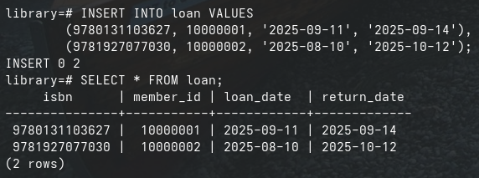
SELECT B.title, M.name  FROM loan L  INNER JOIN book B ON L.isbn = B.isbn  INNER JOIN member M ON L.member_id = M.member_id; | 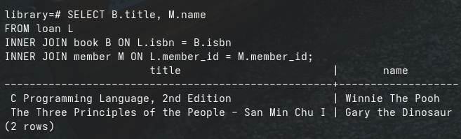
UPDATE loan  SET return_date = '2025-11-10'  WHERE  isbn = 9781927077030  AND  member_id = 10000002;  SELECT * FROM loan; | 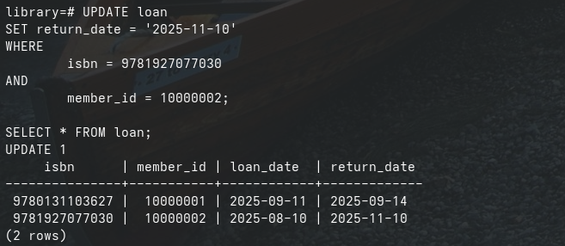
DELETE FROM loan  WHERE  isbn = 9780131103627  AND  member_id = 10000001;  SELECT * FROM loan; | 

