PostgreSQL installation
Screenshot of PostgreSQL installation


DVD rental tables
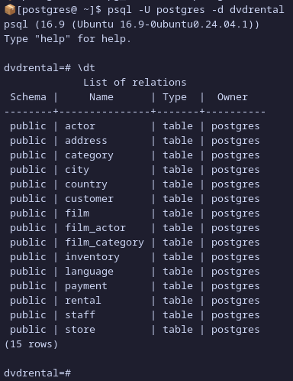

Results of each SQL queries (Rows limited to 40 rows)
  1. Display the first name and last name of all actors.  SELECT first_name, last_name FROM actor LIMIT 40;  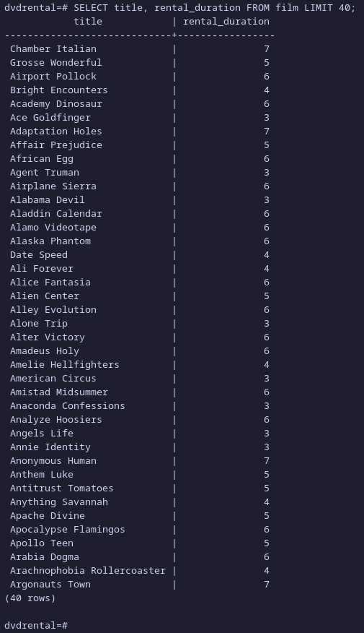 | 2. Show the title and rental duration of all films.  SELECT title, rental_duration FROM film LIMIT 40;

3. List the names and emails of all customers who live in the city “London.”
SQL command:
SELECT first_name, last_name, email
FROM customer CU
INNER JOIN address A ON A.address_id = CU.address_id
INNER JOIN city C ON C.city_id = A.city_id
WHERE C.city = 'London';
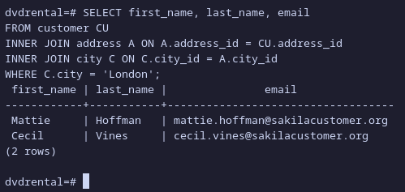

4. Show the film titles that have a rental rate greater than $4.00.  SELECT title FROM film WHERE rental_rate > 4.00 LIMIT 40;  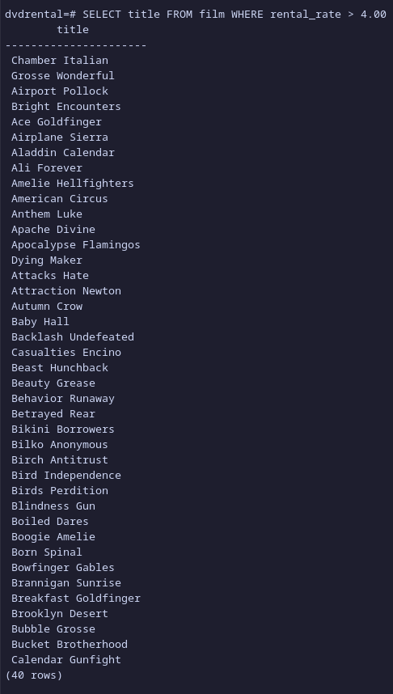 | 5. Find all films that are in the “Comedy” category.  SELECT *  FROM film F  INNER JOIN film_category FC ON FC.film_id = F.film_id  WHERE FC.category_id = 5  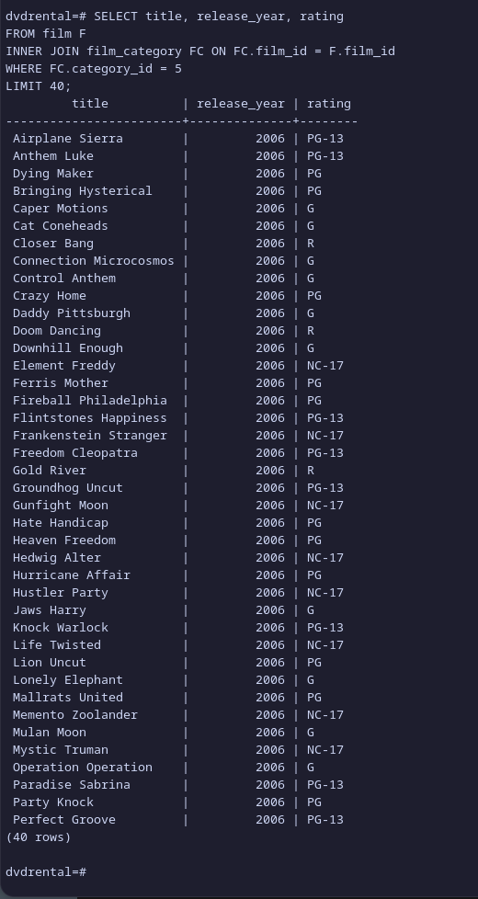  LIMIT 40;

