ER Diagram

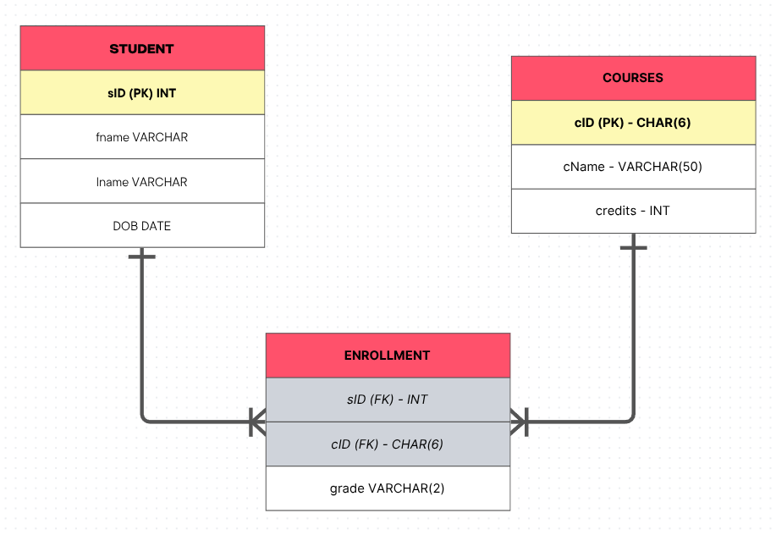
SQL Queries

SQL Query | Output
CREATE DATABASE cmkl;  CREATE TABLE students (  sID INT PRIMARY KEY,  fname VARCHAR(20) NOT NULL,  lname VARCHAR(30) NOT NULL,  DOB DATE  );  CREATE TABLE courses (  cID CHAR(6) PRIMARY KEY,  cName VARCHAR(50) NOT NULL,  credits INT  );  CREATE TABLE enrollment (  sID INT REFERENCES students(sID),  cID CHAR(6) REFERENCES courses(cID),  grade VARCHAR(2),  PRIMARY KEY (sID, cID)  ); | 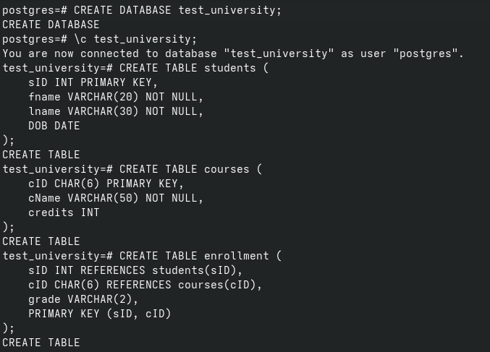
Insert 3 students and 2 courses.  INSERT INTO students VALUES  (1000, 'Peter', 'Parker', '2001-08-10'),  (1001, 'Miles', 'Morales', '2001-08-03'),  (1002, 'Gwen', 'Stacy', '2001-04-18');  INSERT INTO courses VALUES  ('2sf3Lf', 'Physics I', 5),  ('XjxDA6', 'Chemistry I', 6),  ('3lScza', 'Biology I', 4);  SELECT * FROM students;  SELECT * FROM courses; | 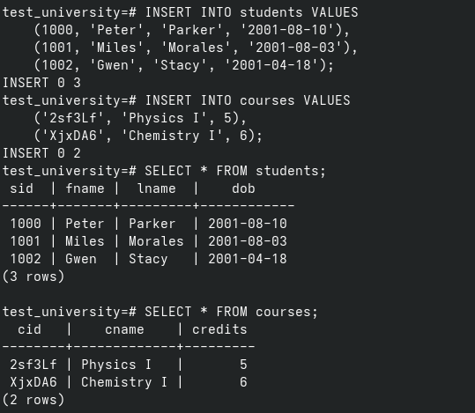
Enroll students into courses with grades.  INSERT INTO enrollment VALUES  (1000, 'XjxDA6', 'A'),  (1000, '2sf3Lf', 'A+'),  (1001, '2sf3Lf', 'B'),  (1002, 'XjxDA6', 'A'),  (1002, '2sf3Lf', 'A+');  SELECT * FROM enrollment; | 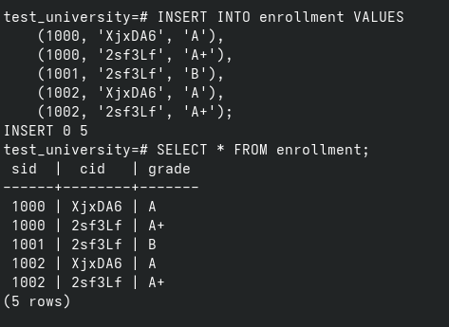
Retrieve all students with their enrolled courses.  SELECT  st.fname,  st.lname,  STRING_AGG  (  c.cName, ','  ) enrolled  FROM students st  INNER JOIN enrollment e ON e.sID = st.sID  INNER JOIN courses c ON c.cID = e.cID  GROUP BY st.fname, st.lname; | 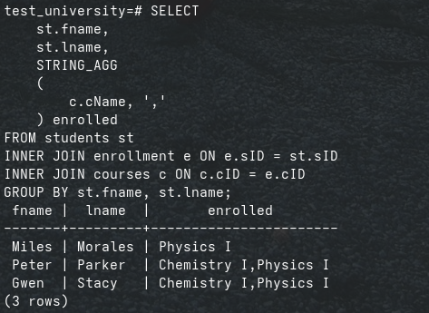
Update one student’s grade.  UPDATE enrollment  SET grade = 'A'  WHERE  sID = 1001  AND  cID = '2sf3Lf';  SELECT * FROM enrollment; | 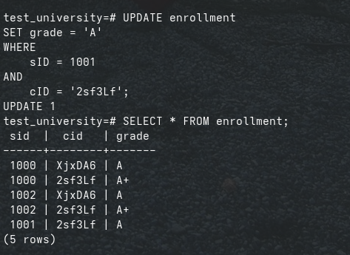
Delete one enrollment record.  SELECT * FROM enrollment;  DELETE FROM enrollment  WHERE  sID = 1002  AND  cID = 'XjxDA6';  SELECT * FROM enrollment; | 

