PostgreSQL installation


DVD rental tables
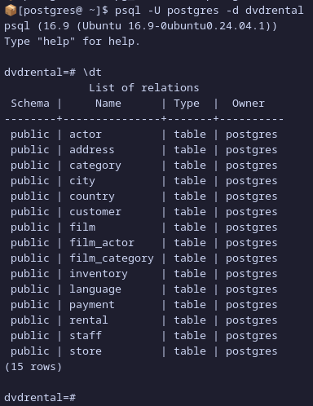

Results of each SQL queries

Display the first name and last name of all actors.
Show the title and rental duration of all films.

List the names and emails of all customers who live in the city “London.”
SQL command:
SELECT first_name, last_name, email
FROM customer CU
INNER JOIN address A ON A.address_id = CU.address_id
INNER JOIN city C ON C.city_id = A.city_id
WHERE C.city = 'London';



Show the film titles that have a rental rate greater than $4.00.
SQL command:

SELECT title FROM film WHERE rental_rate > 4.00;

Find all films that are in the “Comedy” category.

SELECT *
FROM film F
INNER JOIN film_category FC ON FC.film_id = F.film_id
WHERE FC.category_id = 5;

