Question 1
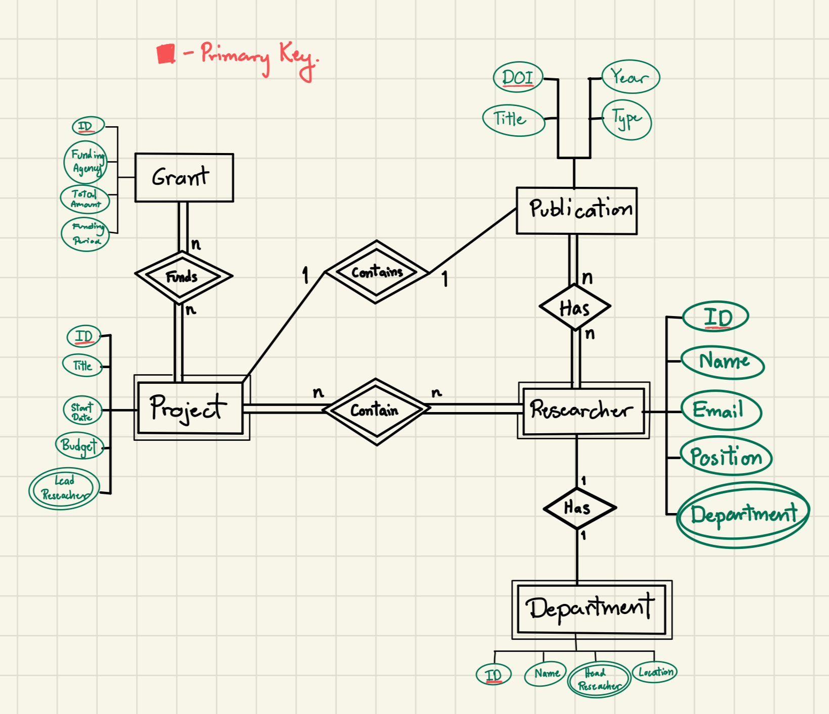
- ER Diagram

- Relationship Schema
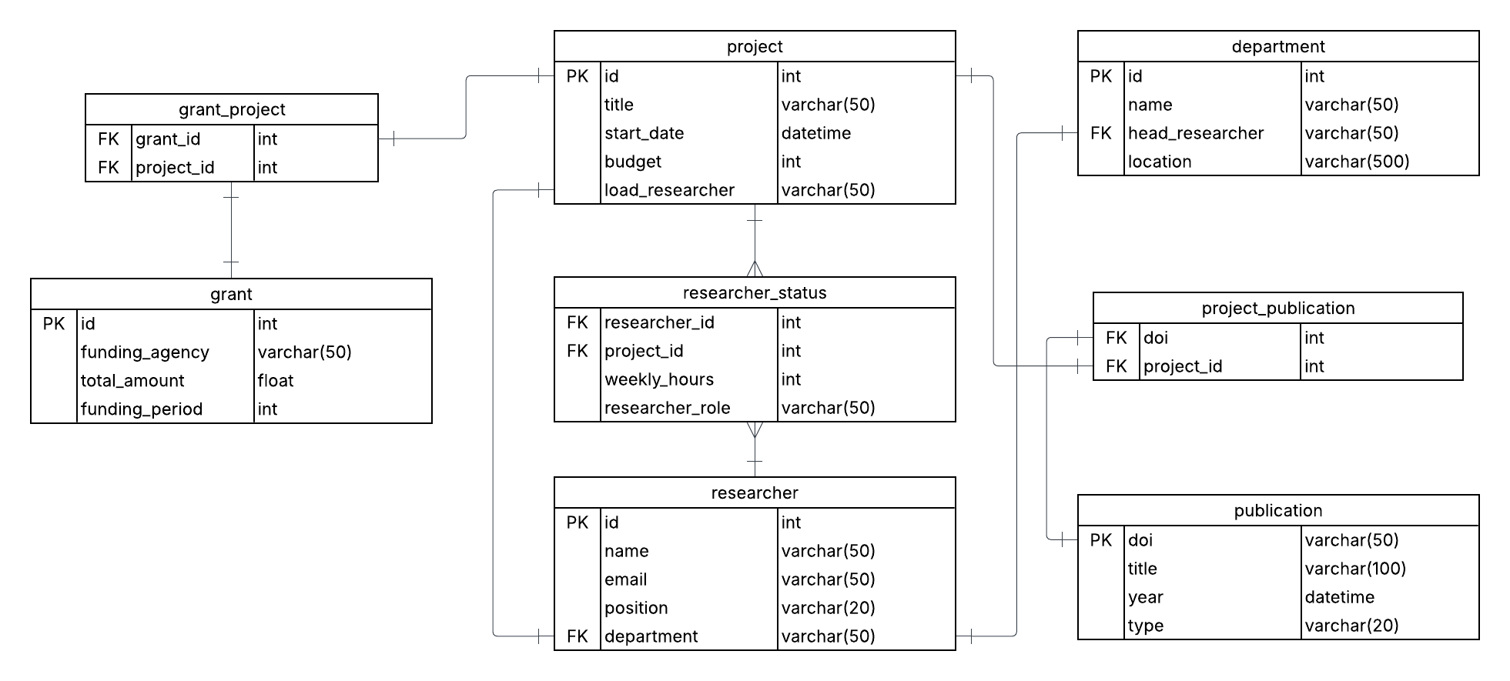
- This schema enforces referential integrity through the usage of several elements, such as, primary keys to keep rows in tables unique; no duplicate entries allowed, foreign keys to organize the relationships between tables in the database.

Question 2

- Functional Dependencies (FDs)
6 functional dependencies
  - ProjectID
  - ResearcherID
  - DepartmentName
  - GrantID
  - PublicationDOI
  - ProjectID & ResearcherID
- 1NF → 2NF → 3NF Normalization
  - 1NF (Remove repeating groups)
    - Project: ProjectID, ProjectTitle
    - Researcher: ResearcherID, ResearcherName, ResearcherEmail, DepartmentName
    - Department: DepartmentName, DepartmentHead
    - Grant: GrantID, GrantAgency, GrantAmount
    - Publication: PublicationDOI, PublicationTable, PubYear
    - Project_Researcher: ResearcherID, Project ID, Researcher_Role, HoursPerWeek
    - Proj_Grant: ProjectID, GrantID
    - Proj_Publication: ProjectId, PublicationDOI

  - 2NF (All data must depend on the Primary key)
Since the table is already in 1NF along with the attributes are partially dependent on a key, the table is indeed in 2NF.
  - 3NF (Remove transitive dependencies)
Here, we would need to separate Departments since there is a transitive dependency of ResearcherID → DepartmentName → DepartmentHead, therefore we must separate them. However, that is already done in 1NF so these tables are in 3NF.

- Final Normalized Schema
The finalized schema would be the following:
  - Projects
    - ProjectID (PK)
    - ProjectTitle
  - Researchers
    - ResearcherID (PK)
    - ResearcherName
    - ResearcherEmail
    - DepartmentName (FK)
  - Departments
    - DepartmentName (PK)
    - DepartmentHead (FK to ResearcherID)
  - Grants
    - GrantID (PK)
    - GrantAgency
    - GrantAmount
  - Publications
    - PublicationDOI (PK)
    - PublicationTitle
    - PubYear
  - Project_Researcher
    - ProjectID, ResearcherID (Composite PK)
    - ResearcherRole
    - HoursPerWeek
  - Proj_Grant
    - ProjectID, GrantID (Composition PK)
  - Proj_Publication
    - ProjectID, PublicationDOI (Composite PK)
- SQL Implementation

CREATE TABLE Projects(
ProjectID INT PRIMARY KEY,
ProjectTitle VARCHAR(200) NOT NULL
);

CREATE TABLE Researcher (
ResearcherID INT PRIMARY KEY,
ResearcherName VARCHAR(200) NOT NULL,
ResearcherEmail VARCHAR(200) UNIQUE NOT NULL,
DepartmentName VARCHAR(100) NOT NULL,
FOREIGN KEY (DepartmentName) REFERENCES Department(DepartmentName)
);

CREATE TABLE Department (
DepartmentName VARCHAR(100) PRIMARY KEY,
DepartmentHead INT NOT NULL,
FOREIGN KEY (DepartmentHead) REFERENCES Researcher(ResearcherID)
);

CREATE TABLE Grant (
GrantID INT PRIMARY KEY,
GrantAgency VARCHAR(200) NOT NULL,
GrantAmount FLOAT
);

CREATE TABLE Publication (
PublicationDOI VARCHAR(100) PRIMARY KEY,
PublicationTitle VARCHAR(200) NOT NULL,
PubYear INT
);

CREATE TABLE Project_Researcher (
ProjectID INT,
ResearcherID INT,
ResearcherRole VARCHAR(100) NOT NULL,
HoursPerWeek INT,
PRIMARY KEY (ProjectID, ResearcherID),
FOREIGN KEY (ProjectID) REFERENCES Project(ProjectID),
FOREIGN KEY (ResearcherID) REFERENCES Researcher(ResearcherID)
);
CREATE TABLE Proj_Grant (
ProjectID INT,
GrantID INT,
PRIMARY KEY (ProjectID, GrantID),
FOREIGN KEY (ProjectID) REFERENCES Project(ProjectID),
FOREIGN KEY (GrantID) REFERENCES Grant(GrantID)
);

CREATE TABLE Proj_Publication (
ProjectID INT,
PublicationDOI VARCHAR(100),
PRIMARY KEY (ProjectID, PublicationDOI),
FOREIGN KEY (ProjectID) REFERENCES Projects(ProjectID),
FOREIGN KEY (PublicationDOI) REFERENCES Publications(PublicationDOI)
);

